**ОТЧЕТ**

**«Разработка программно-аппаратного комплекса для модернизации наземной части комплекса управления БпЛА»**

# Структура, функционал и назначение программно-аппаратного комплекса

Программно-аппаратный комплекс модернизации системы управления имеет следующий состав:

*Аппаратная часть:*

* персональный компьютер (ПК);
* устройство ввода для взаимодействия с графическим интерфейсом программы (манипулятор типа «мышь»);
* устройство ввода для управления полетом («джойстик»);
* макетная плата на базе микроконтроллера Atmel Mega 324 («Arduino Uno»).

Программная часть:

* системное программное окружение (ОС Windows/Linux, Python3.9, библиотека customtkinter, библиотека serial);
* графическая оболочка «Joy_fly_control»;
* программа микроконтроллера (прошивка).

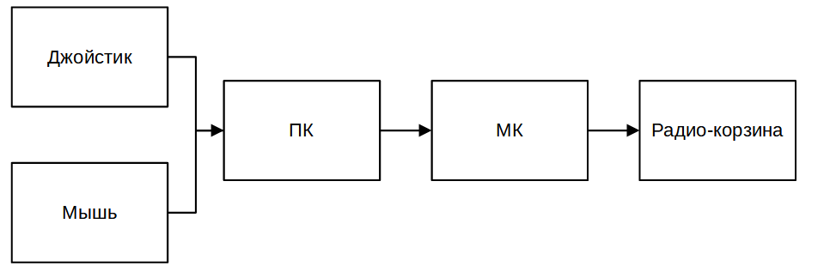

ПК предназначен для подключения джойстика, мыши и микроконтроллера, а также реализации программы «Joy_fly_control». Микроконтроллер (МК) предназначен для преобразования и формирования на своих выводах управляющих воздействий с ПК в сигналы PWM или S-BUS.

Программа «Joy_fly_control» предназначена для осуществления управления полетом в ручном режиме, предоставляя в этих целях пользовательский интерфейс для конфигурирования настроек и управления процессом чтения-передачи данных. Для этого она выполняет следующие функции:

* обнаружение подключенных устройств ввода команд (джойстиков);
* осуществление привязки клавиш джойстика к каналам управления;
* осуществление настройки кривой отклика (чувствительности в заданном диапазоне) стиков для каждого канала;
* сохранение и загрузку настроек привязки клавиш к каналам и кривых отклика по всем каналам;
* управление потоками чтения/записи аппаратных частей программно-аппаратного комплекса;
* чтение событий нажатия клавиш джойстика, назначенных по каналам, считывание положений стиков и осуществление масштабирования в соответствии с кривой чувствительности соответствующего канала;
* передача масштабированных в соответствии с кривой отклика значений стиков в последовательный порт.

# Описание графического интерфейса программы

При запуске программы «Joy_fly_control» появляется главное окно, состоящее из окна навигации в левой части главного окна и трех вкладок:

* «Каналы»;
* «Настройки»;
* «Полет».

Окно программы при запуске показано на рисунке ниже.

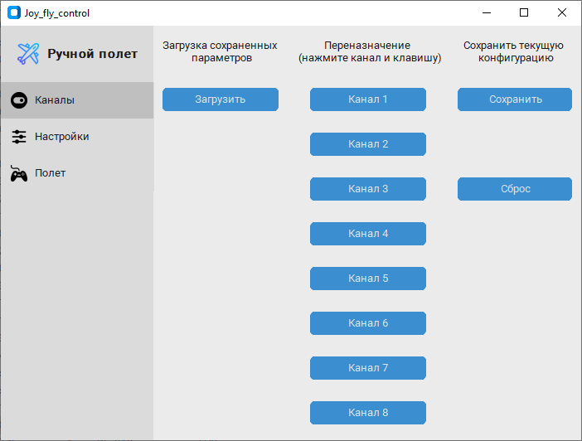

Окно программы «Joy_fly_control» после запуска, открыта вкладка конфигурирования каналов

Окно «Каналы» предоставляет пользователю возможность осуществить привязку каналов к осям стиков и клавишам подключенного джойстика.

Процесс привязки каналов к клавишам осуществляется следующим образом. Чтобы привязать канал к клавише необходимо нажать кнопку соответствующего канала левой кнопкой мыши. После этого кнопка с номером канала изменит цвет, и программа будет ожидать события нажатия клавиши джойстика. Пользователю необходимо нажать нужную клавишу джойстика, после чего кнопка с номером канала изменит цвет на первоначальный, а в ее названии помимо номера канала появится название привязанной клавиши или оси стика джойстика.

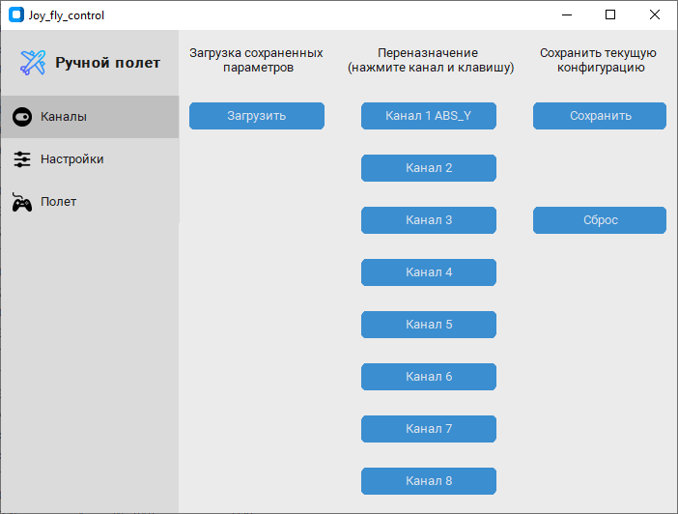

Каналу 1 назначен ввод с оси Y левого стика джойстика

При необходимости можно переназначить клавишу для любого канала повторением вышеописанных действий.

Привязка всех каналов может быть сброшена нажатием кнопки «Сброс».

После настройки всех каналов, текущие привязки могут быть сохранены нажатием кнопки «Сохранить». Настройки храниться на жестком диске в папке с программой в файле «channel_settings.npy».

Сохраненные настройки конфигурации каналов могут быть загружены нажатием кнопки «Загрузить».

После конфигурирования каналов можно перейти к настройке чувствительности стиков по осям, перейдя в навигационном окне слева на вкладку «Настройки». Если каналы не сконфигурированы, можно произвести настройки с привязкой по номеру канала, которые после привязки в окне «Каналы» будут применены к данным с соответствующего выхода джойстика.

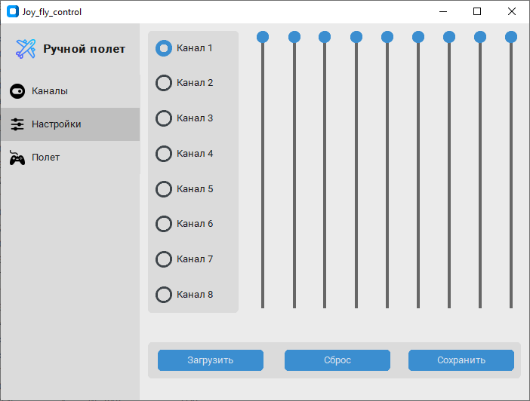

Вкладка конфигурирования кривой отклика стиков, - каналы не привязаны к клавишам джойстика

Если каналы сконфигурированы, то информация о назначенных каналах будет отображаться, как показано на рисунке ниже.

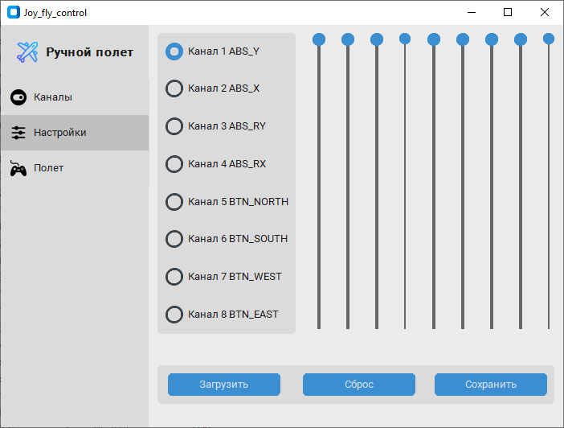

Вкладка конфигурирования кривой отклика стиков, - каналы привязаны к клавишам джойстика

Вкладка «Настройки» имеет три зоны: зона выбора конфигурируемого канала, зона с 9 подвижными движками для настройки, зона с кнопками «Загрузить», «Сброс», «Сохранить».

Пример настройки кривой отклика канала 1 показан на рисунке ниже.

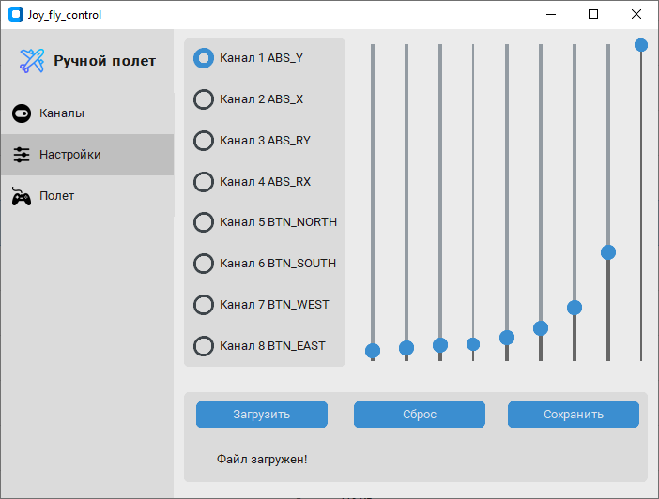

Пример настройки канала 1

Настройки чувствительности каждого канала хранятся в двумерной матрице (таблице) self.stick_sensity. Размер матрицы составляет 8 строк (по числу каналов) на 9 столбцов (по числу движков в окне настройки). Для примера на рисунке выше значения движков в составляют:

stick_sensity[0, :] = [0.07486631, 0.08544304, 0.09651899, 0.10759494, 0.12025316, 0.14240506, 0.20886076, 0.39398734, 1]

Настройка чувствительности организована следующим образом: весь диапазон стика разбивается на две части от среднего положения. Каждый поддиапазон разбивается на 8 равных участков, за настройку которых отвечают движки в окне настройки. После настройки, значения движков (9 шт.) каждого из каналов подвергаются полиномиальной аппроксимации.

На рисунке ниже оранжевыми точками показаны значения движков, а синей линией показана аппроксимирующая кривая.

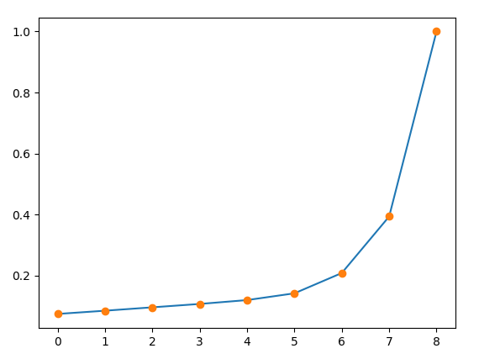

В дальнейшем, при работе выходной сигнал джойстика каждого поддиапазона подвергается преобразованию в соответствии с функцией, аппроксимирующей настройки чувствительности для данного канала.

Сравнение исходной и скорректированной кривой отклика показано на рисунке ниже.

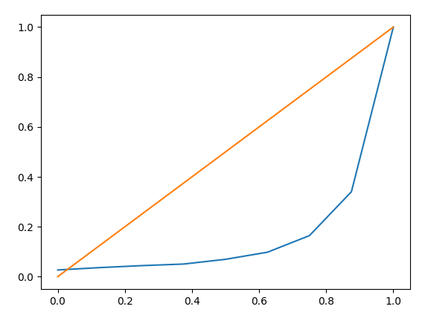

Сравнение исходной (линейной, -оранжевая линия) и скорректированной (голубая линия) кривой отклика стика

Значения stick_sensity изменяются путем выбора канала и настройкой уровней. Настройка уровней и сброс параметров производятся только для выбранного канала, а сохранение настроек производится для всех каналов единовременно.

На рисунке ниже показаны примеры настройки кривой отклика.

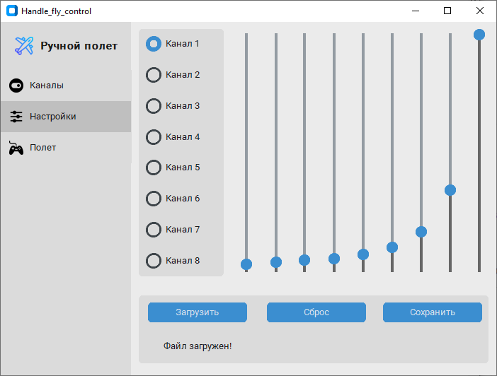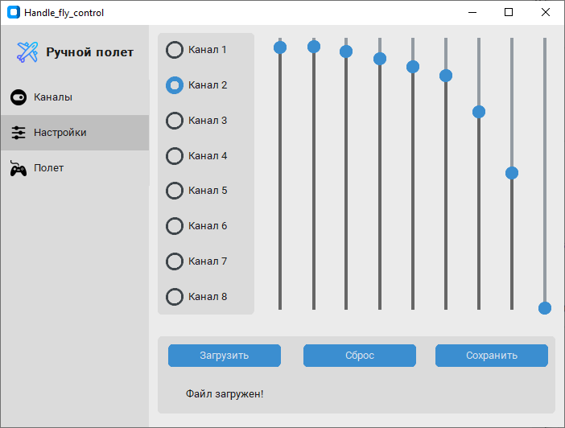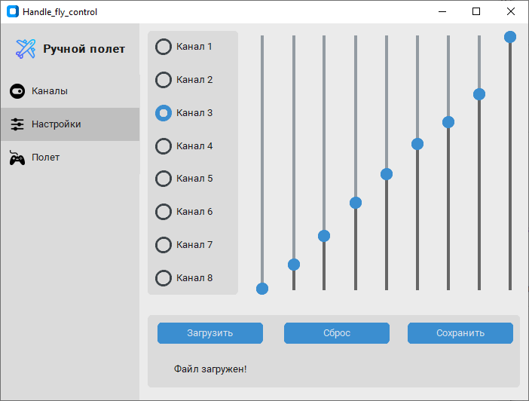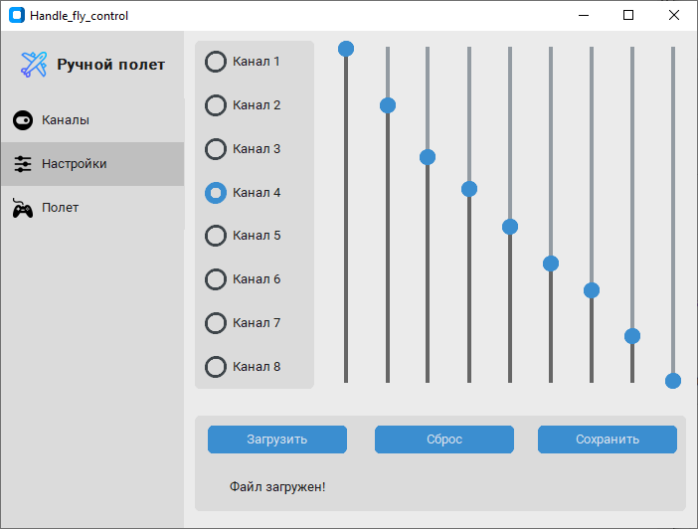

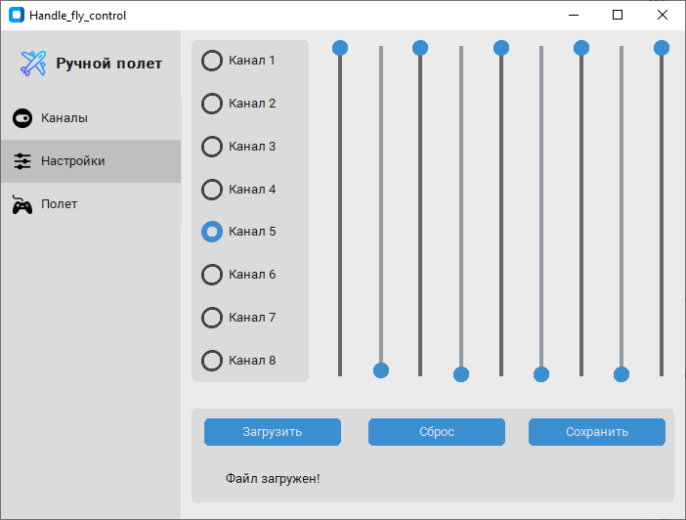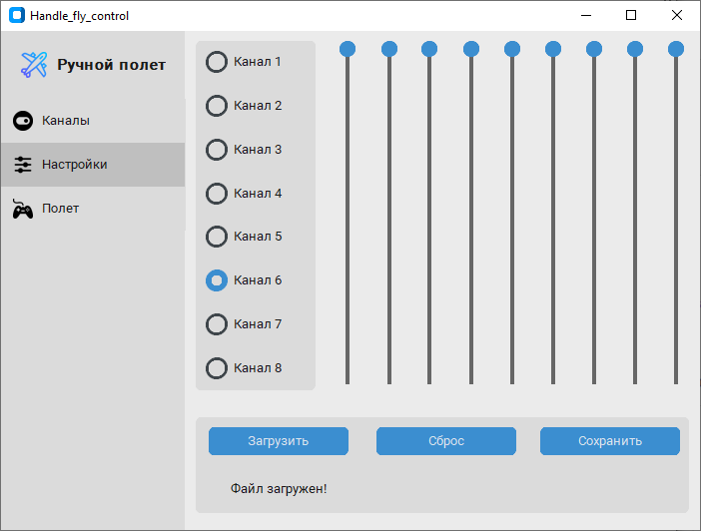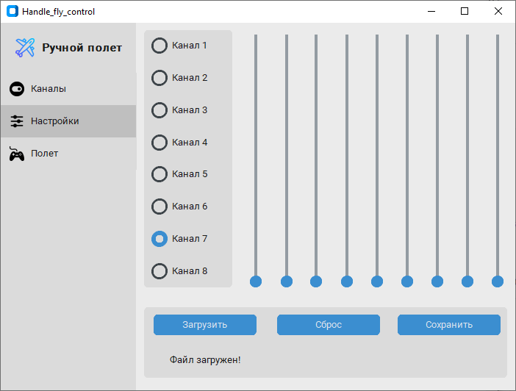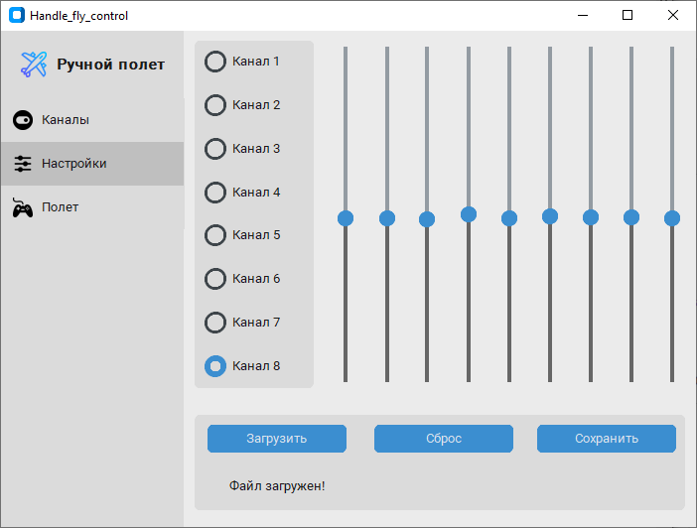

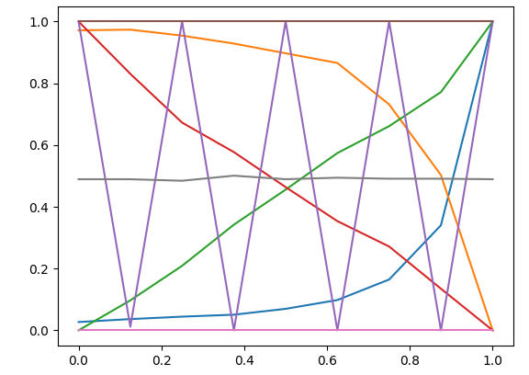

Примеры настроек кривой отклика и соответствующие им функции аппроксимации

После конфигурирования настройки могут быть сохранены кнопкой «Сохранение» и в дальнейшем загружены кнопкой «Загрузить».

После настройки привязки каналов и чувствительности можно преходить к запуску потока считывания, масштабирования и предачи данных на микроконтроллер (в последовательный порт) на вкладке «Полет».

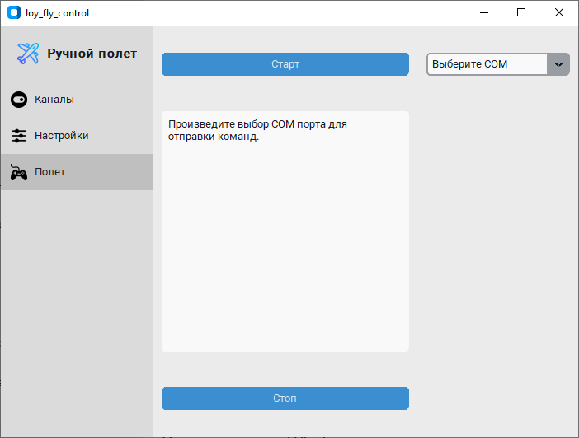

Окно «Полет» после перехода на него в области навигации

Окно «Полет» имеет клавиши «Старт» / «Стоп», область вывода пользовательских сообщений, а также выпадающее меню для выбора СОМ порта, в который будут отправляться команды.

Для начала ручного управления необходимо в выпадающем меню справа выбрать СОМ порт, к которому подключена плата микроконтроллера. Программа сканирует список доступных к открытию СОМ портов при запуске, а также при переходе на вкладку «Полет». Таким образом, в выпадающем списке будут содержаться все доступные к подключению СОМ порты. Для выбора порта, к которому подключено устройство можно воспользоваться диспетчером устройств.

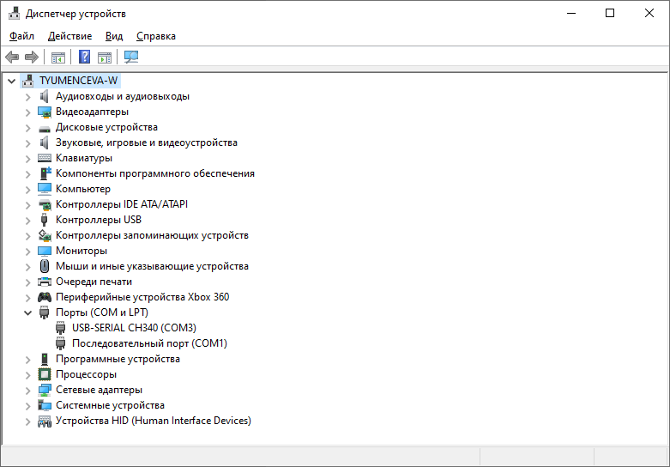

Микроконтроллер подключен к СОМ3

После выбора порта программа в диалоговом окне сообщит о том, что сделан выбор порта и предложит нажать кнопку старт.

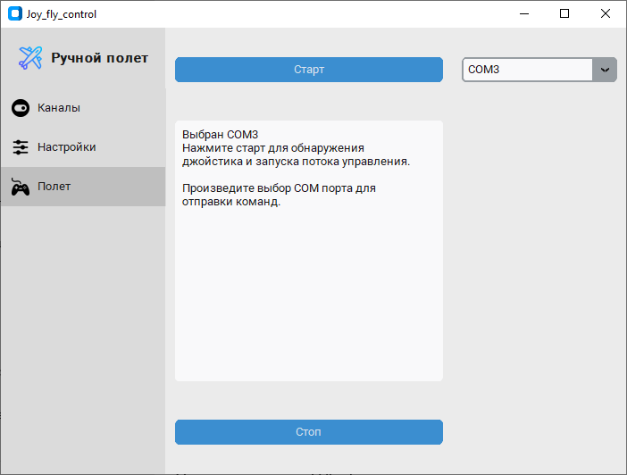

После нажатия кнопки «Старт» программа запустит отдельный вычислительный поток, в котором производится считывание сигналов (событий нажатия клавиш или изменения положения стиков по осям) с джойстика, их фильтрация в соответствии с привязкой к каналам, произведенной в окне «Каналы», масштабирование в соответствии с настройками для каналов, произведенными в окне «Настройки» и передача масштабированных значений с номером канала в последовательный порт.

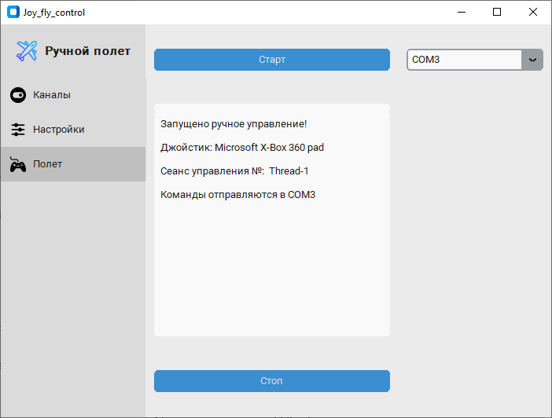

Вид окна после нажатия кнопки «Старт»

При нажатии кнопки «Стоп», поток считывания преобразования и отправки данных будет остановлен.

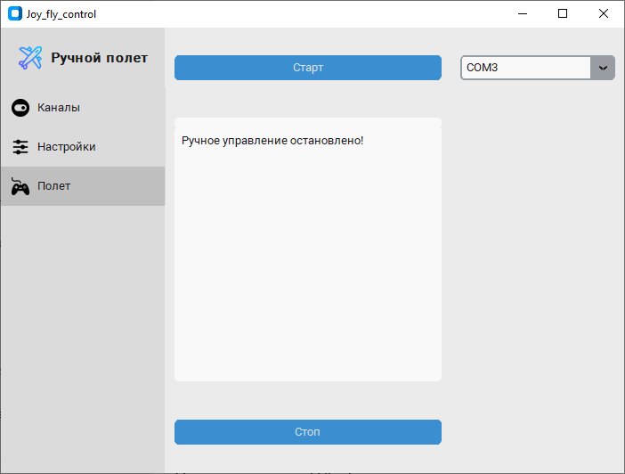

# Установка

Для Windows

Установка пакетов для работы и первичное конфигурирование (требует подключения к сети Internet).

1. Скачать и установить Python3.9

<https://www.python.org/downloads/release/python-390/>

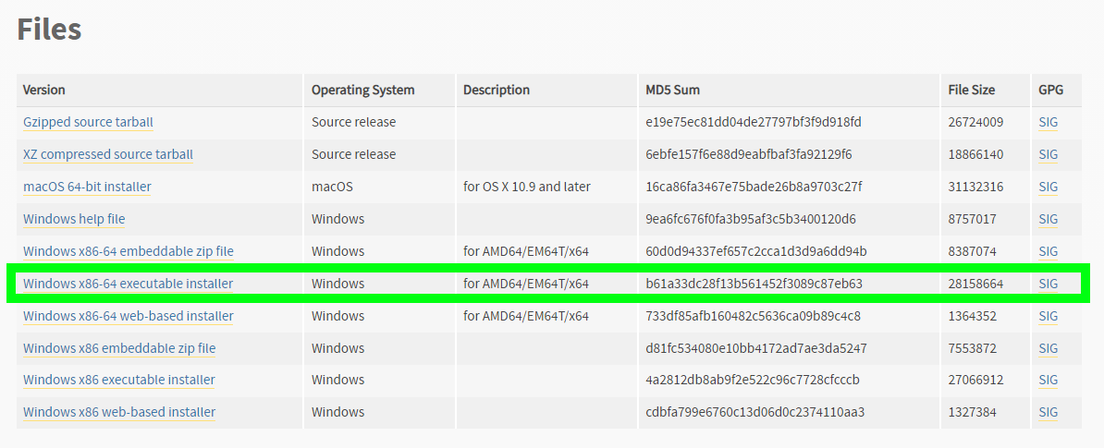

1. Установить библиотеку inputs

Запустить командную строку, например, сочетанием клавиш «Windows» + «R», или из диспетчера задач.

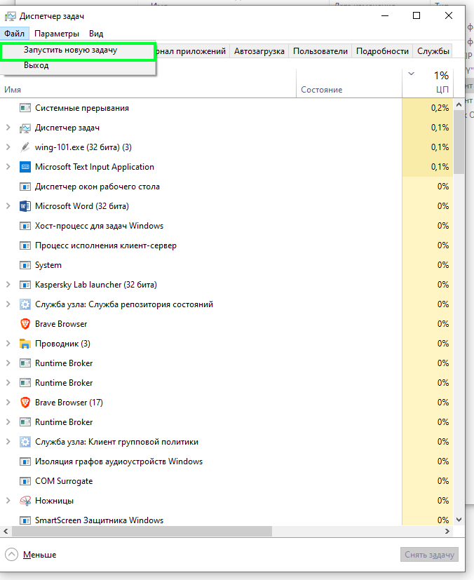

Ввести в командной строке команду: *Cmd*

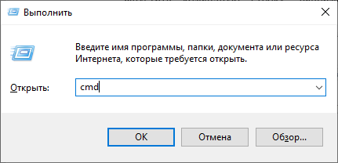

В окне cmd.exe ввести команду: *pip install inputs*

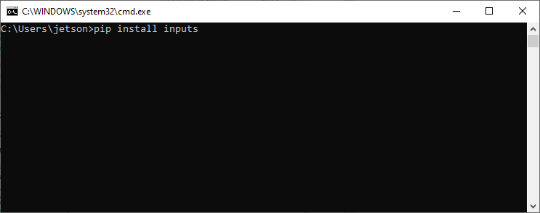

Нажать Enter и дождаться сообщения о завершении установки: *Successfully installed inputs*

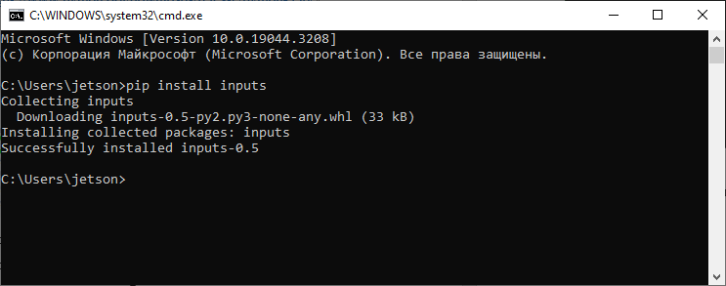

pip install pyserial

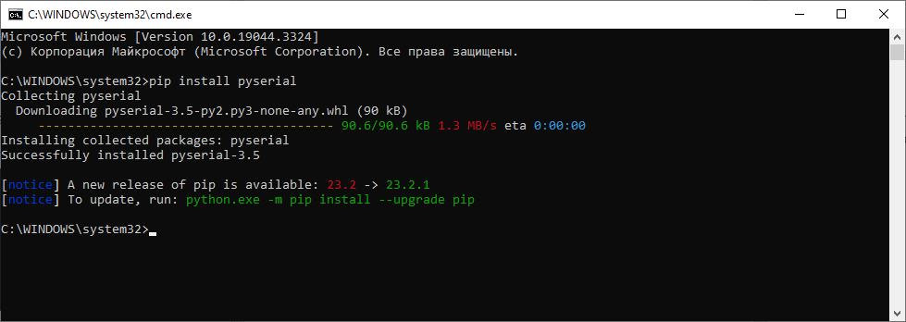

Под windows джойстик «logitech gamepad f310» нужно перевести в режим «X» переключателем на обратной стороне джойстика.

# Код программы «Joy_fly_control»

from __future__ import print_function

import customtkinter

import os

from PIL import Image

import inputs_lib

import threading

from threading import Thread

import time

import serial

import tkinter

import numpy as np

import ctypes

import platform

import serial

class App(customtkinter.CTk):

def __init__(self):

super().__init__()

self.WIN = True if platform.system() == 'Windows' else False

self.NIX = True if platform.system() == 'Linux' else False

self.trig = 1

self.channel_list = ['', '', '', '', '', '', '', '']

self.stick_sensity = np.array([[1., 1., 1., 1., 1., 1., 1., 1., 1.],

[1., 1., 1., 1., 1., 1., 1., 1., 1.],

[1., 1., 1., 1., 1., 1., 1., 1., 1.],

[1., 1., 1., 1., 1., 1., 1., 1., 1.],

[1., 1., 1., 1., 1., 1., 1., 1., 1.],

[1., 1., 1., 1., 1., 1., 1., 1., 1.],

[1., 1., 1., 1., 1., 1., 1., 1., 1.],

[1., 1., 1., 1., 1., 1., 1., 1., 1.]])

self.aprox_models = np.ones((8, 10), dtype='float')

self.com_port = ''

self.title("Joy_fly_control")

self.geometry("700x500")

# set grid layout 1x2

self.grid_rowconfigure(0, weight=1)

self.grid_columnconfigure(1, weight=1)

# load images with light and dark mode image

image_path = os.path.join(os.path.dirname(

os.path.realpath(__file__)), "test_images")

self.logo_image = customtkinter.CTkImage(Image.open(os.path.join(

image_path, "CustomTkinter_logo_single.png")), size=(26, 26))

self.image_icon_image = customtkinter.CTkImage(Image.open(

os.path.join(image_path, "image_icon_light.png")), size=(20, 20))

self.joystik_image = customtkinter.CTkImage(light_image=Image.open(os.path.join(image_path, "joystik_dark.png")),

dark_image=Image.open(os.path.join(image_path, "joystik_light.png")), size=(20, 20))

self.chat_image = customtkinter.CTkImage(light_image=Image.open(os.path.join(image_path, "chat_dark.png")),

dark_image=Image.open(os.path.join(image_path, "chat_light.png")), size=(20, 20))

self.add_user_image = customtkinter.CTkImage(light_image=Image.open(os.path.join(image_path, "add_user_dark.png")),

dark_image=Image.open(os.path.join(image_path, "add_user_light.png")), size=(20, 20))

# create navigation frame

self.navigation_frame = customtkinter.CTkFrame(self, corner_radius=0)

self.navigation_frame.grid(row=0, column=0, sticky="nsew")

self.navigation_frame.grid_rowconfigure(4, weight=1)

self.navigation_frame_label = customtkinter.CTkLabel(self.navigation_frame, text=" Ручной полет", image=self.logo_image,

compound="left", font=customtkinter.CTkFont(size=15, weight="bold"))

self.navigation_frame_label.grid(row=0, column=0, padx=20, pady=20)

self.joystik_button = customtkinter.CTkButton(self.navigation_frame, corner_radius=0, height=40, border_spacing=10, text="Полет",

fg_color="transparent", text_color=("gray10", "gray90"), hover_color=("gray70", "gray30"),

image=self.joystik_image, anchor="w", command=self.joystik_button_event)

self.joystik_button.grid(row=3, column=0, sticky="ew")

self.chanel_selector_button = customtkinter.CTkButton(self.navigation_frame, corner_radius=0, height=40, border_spacing=10, text="Каналы",

fg_color="transparent", text_color=("gray10", "gray90"), hover_color=("gray70", "gray30"),

image=self.chat_image, anchor="w", command=self.chanel_selector_button_event)

self.chanel_selector_button.grid(row=1, column=0, sticky="ew")

self.settings_button = customtkinter.CTkButton(self.navigation_frame, corner_radius=0, height=40, border_spacing=10, text="Настройки",

fg_color="transparent", text_color=("gray10", "gray90"), hover_color=("gray70", "gray30"),

image=self.add_user_image, anchor="w", command=self.settings_button_event)

self.settings_button.grid(row=2, column=0, sticky="ew")

# create joystik frame

self.joystik_frame = customtkinter.CTkFrame(

self, corner_radius=0, fg_color="transparent")

self.joystik_frame.grid_columnconfigure(0, weight=3)

self.joystik_frame.grid_columnconfigure(1, weight=1)

self.joystik_frame.grid_rowconfigure(0, weight=1)

self.joystik_frame.grid_rowconfigure(1, weight=2)

self.joystik_frame.grid_rowconfigure(2, weight=1)

self.joystik_frame_button_1 = customtkinter.CTkButton(

self.joystik_frame, text="Старт", command=self.button_start_event)

self.joystik_frame_button_1.grid(

row=0, column=0, padx=10, pady=10, sticky="ew")

self.textbox = customtkinter.CTkTextbox(self.joystik_frame)

self.textbox.grid(row=1, column=0, padx=(

10, 10), pady=(10, 10), sticky="nsew")

if self.com_port == '':

self.textbox.insert(

"0.0", "Произведите выбор СОМ порта для \nотправки команд.\n\n")

else:

self.textbox.insert(

"0.0", 'Выбран ' + self.com_port + "\nНажмите старт для обнаружения \nджойстика и запуска потока управления.\n\n")

self.joystik_frame_button_2 = customtkinter.CTkButton(

self.joystik_frame, text="Стоп", command=self.button_stop_event)

self.joystik_frame_button_2.grid(

row=2, column=0, padx=10, pady=10, sticky="ew")

self.combobox_com = customtkinter.CTkComboBox(

self.joystik_frame, values=self.scan_com(), command=self.combobox_com_event)

self.combobox_com.grid(

row=0, column=1, padx=10, pady=10, sticky="ew")

self.combobox_com.set("Выберите СОМ")

# create second frame

self.second_frame = customtkinter.CTkFrame(

self, corner_radius=0, fg_color="transparent")

self.second_frame.grid_columnconfigure(0, weight=1)

self.second_frame.grid_columnconfigure(1, weight=1)

self.second_frame.grid_columnconfigure(2, weight=1)

self.second_frame.grid_rowconfigure(

[0, 1, 2, 3, 4, 5, 6, 7, 8, 9], weight=1)

self.second_frame_label_0 = customtkinter.CTkLabel(

self.second_frame, text='Загрузка сохраненных \n параметров', width=120, height=25, fg_color="transparent", corner_radius=0)

self.second_frame_label_0.grid(row=0, column=0, padx=10, pady=10)

self.second_frame_label_1 = customtkinter.CTkLabel(

self.second_frame, text='Переназначение \n (нажмите канал и клавишу)', width=120, height=25, fg_color="transparent", corner_radius=0)

self.second_frame_label_1.grid(row=0, column=1, padx=10, pady=13)

self.second_frame_label_2 = customtkinter.CTkLabel(

self.second_frame, text='Сохранить текущую \n конфигурацию', width=120, height=25, fg_color="transparent", corner_radius=0)

self.second_frame_label_2.grid(row=0, column=2, padx=10, pady=10)

self.second_frame_btn_download = customtkinter.CTkButton(

self.second_frame, text="Загрузить", command=self.btn_download_event)

self.second_frame_btn_download.grid(

row=1, column=0, padx=10, pady=10)

self.second_frame_btn_ch_1 = customtkinter.CTkButton(

self.second_frame, text="Канал 1", command=self.btn_ch_1_event)

self.second_frame_btn_ch_1.grid(row=1, column=1, padx=10, pady=10)

self.second_frame_btn_ch_2 = customtkinter.CTkButton(

self.second_frame, text="Канал 2", command=self.btn_ch_2_event)

self.second_frame_btn_ch_2.grid(row=2, column=1, padx=10, pady=10)

self.second_frame_btn_ch_3 = customtkinter.CTkButton(

self.second_frame, text="Канал 3", command=self.btn_ch_3_event)

self.second_frame_btn_ch_3.grid(row=3, column=1, padx=10, pady=10)

self.second_frame_btn_ch_4 = customtkinter.CTkButton(

self.second_frame, text="Канал 4", command=self.btn_ch_4_event)

self.second_frame_btn_ch_4.grid(row=4, column=1, padx=10, pady=10)

self.second_frame_btn_ch_5 = customtkinter.CTkButton(

self.second_frame, text="Канал 5", command=self.btn_ch_5_event)

self.second_frame_btn_ch_5.grid(row=5, column=1, padx=10, pady=10)

self.second_frame_btn_ch_6 = customtkinter.CTkButton(

self.second_frame, text="Канал 6", command=self.btn_ch_6_event)

self.second_frame_btn_ch_6.grid(row=6, column=1, padx=10, pady=10)

self.second_frame_btn_ch_7 = customtkinter.CTkButton(

self.second_frame, text="Канал 7", command=self.btn_ch_7_event)

self.second_frame_btn_ch_7.grid(row=7, column=1, padx=10, pady=10)

self.second_frame_btn_ch_8 = customtkinter.CTkButton(

self.second_frame, text="Канал 8", command=self.btn_ch_8_event)

self.second_frame_btn_ch_8.grid(row=8, column=1, padx=10, pady=10)

self.second_frame_btn_save = customtkinter.CTkButton(

self.second_frame, text="Сохранить", command=self.btn_save_event)

self.second_frame_btn_save.grid(row=1, column=2, padx=10, pady=10)

self.second_frame_btn_reset = customtkinter.CTkButton(

self.second_frame, text="Сброс", command=self.btn_reset_event)

self.second_frame_btn_reset.grid(row=3, column=2, padx=10, pady=10)

# create third frame

self.third_frame = customtkinter.CTkFrame(

self, corner_radius=0, fg_color="transparent")

self.third_frame.grid_columnconfigure(

[0, 1, 2, 3, 4, 5, 6, 7, 8, 9], weight=1)

self.third_frame.grid_rowconfigure(0, weight=1)

self.third_frame.grid_rowconfigure(1, weight=1)

self.channel_frame = customtkinter.CTkFrame(self.third_frame)

self.channel_frame.grid(

row=0, column=0, padx=10, pady=(10, 10), sticky="nsw")

self.channel_frame.grid_columnconfigure(1, weight=1)

self.channel_frame.grid_rowconfigure(

[0, 1, 2, 3, 4, 5, 6, 7], weight=1)

self.radiobutton_var = customtkinter.IntVar(value=0)

self.radiobutton_1 = customtkinter.CTkRadioButton(

self.channel_frame, text='Канал 1' + self.channel_list[0], command=self.radiobutton_event, variable=self.radiobutton_var, value=0)

self.radiobutton_1.grid(

row=0, column=0, padx=10, pady=10, sticky="w")

self.radiobutton_2 = customtkinter.CTkRadioButton(

self.channel_frame, text='Канал 2', command=self.radiobutton_event, variable=self.radiobutton_var, value=1)

self.radiobutton_2.grid(

row=1, column=0, padx=10, pady=10, sticky="w")

self.radiobutton_3 = customtkinter.CTkRadioButton(

self.channel_frame, text='Канал 3', command=self.radiobutton_event, variable=self.radiobutton_var, value=2)

self.radiobutton_3.grid(

row=2, column=0, padx=10, pady=10, sticky="w")

self.radiobutton_4 = customtkinter.CTkRadioButton(

self.channel_frame, text='Канал 4', command=self.radiobutton_event, variable=self.radiobutton_var, value=3)

self.radiobutton_4.grid(

row=3, column=0, padx=10, pady=10, sticky="w")

self.radiobutton_5 = customtkinter.CTkRadioButton(

self.channel_frame, text='Канал 5', command=self.radiobutton_event, variable=self.radiobutton_var, value=4)

self.radiobutton_5.grid(

row=4, column=0, padx=10, pady=10, sticky="w")

self.radiobutton_6 = customtkinter.CTkRadioButton(

self.channel_frame, text='Канал 6', command=self.radiobutton_event, variable=self.radiobutton_var, value=5)

self.radiobutton_6.grid(

row=5, column=0, padx=10, pady=10, sticky="w")

self.radiobutton_7 = customtkinter.CTkRadioButton(

self.channel_frame, text='Канал 7', command=self.radiobutton_event, variable=self.radiobutton_var, value=6)

self.radiobutton_7.grid(

row=6, column=0, padx=10, pady=10, sticky="w")

self.radiobutton_8 = customtkinter.CTkRadioButton(

self.channel_frame, text='Канал 8', command=self.radiobutton_event, variable=self.radiobutton_var, value=7)

self.radiobutton_8.grid(

row=7, column=0, padx=10, pady=10, sticky="w")

self.slider_1 = customtkinter.CTkSlider(

self.third_frame, command=self.slider_1_callback, from_=0, to=1, orientation="vertical")

self.slider_1.grid(row=0, column=1, padx=10, pady=10, sticky='nsw')

self.slider_1.set(self.stick_sensity[self.radiobutton_var.get(), 0])

self.slider_2 = customtkinter.CTkSlider(

self.third_frame, command=self.slider_2_callback, from_=0, to=1, orientation="vertical")

self.slider_2.grid(row=0, column=2, padx=10, pady=10, sticky='nsw')

self.slider_2.set(self.stick_sensity[self.radiobutton_var.get(), 1])

self.slider_3 = customtkinter.CTkSlider(

self.third_frame, command=self.slider_3_callback, from_=0, to=1, orientation="vertical")

self.slider_3.grid(row=0, column=3, padx=10, pady=10, sticky='nsw')

self.slider_3.set(self.stick_sensity[self.radiobutton_var.get(), 2])

self.slider_4 = customtkinter.CTkSlider(

self.third_frame, command=self.slider_4_callback, from_=0, to=1, orientation="vertical")

self.slider_4.grid(row=0, column=4, padx=10, pady=10, sticky='nsw')

self.slider_4.set(self.stick_sensity[self.radiobutton_var.get(), 3])

self.slider_5 = customtkinter.CTkSlider(

self.third_frame, command=self.slider_5_callback, from_=0, to=1, orientation="vertical")

self.slider_5.grid(row=0, column=5, padx=10, pady=10, sticky='nsw')

self.slider_5.set(self.stick_sensity[self.radiobutton_var.get(), 4])

self.slider_6 = customtkinter.CTkSlider(

self.third_frame, command=self.slider_6_callback, from_=0, to=1, orientation="vertical")

self.slider_6.grid(row=0, column=6, padx=10, pady=10, sticky='nsw')

self.slider_6.set(self.stick_sensity[self.radiobutton_var.get(), 5])

self.slider_7 = customtkinter.CTkSlider(

self.third_frame, command=self.slider_7_callback, from_=0, to=1, orientation="vertical")

self.slider_7.grid(row=0, column=7, padx=10, pady=10, sticky='nsw')

self.slider_7.set(self.stick_sensity[self.radiobutton_var.get(), 6])

self.slider_8 = customtkinter.CTkSlider(

self.third_frame, command=self.slider_8_callback, from_=0, to=1, orientation="vertical")

self.slider_8.grid(row=0, column=8, padx=10, pady=10, sticky='nsw')

self.slider_8.set(self.stick_sensity[self.radiobutton_var.get(), 7])

self.slider_9 = customtkinter.CTkSlider(

self.third_frame, command=self.slider_9_callback, from_=0, to=1, orientation="vertical")

self.slider_9.grid(row=0, column=9, padx=10, pady=10, sticky='nsw')

self.slider_9.set(self.stick_sensity[self.radiobutton_var.get(), 8])

self.button_frame = customtkinter.CTkFrame(self.third_frame)

self.button_frame.grid(

row=1, column=0, padx=10, pady=(10, 10), sticky="ew", columnspan=10)

self.button_frame.grid_columnconfigure(

[self.radiobutton_var.get(), 1], weight=1)

self.button_frame.grid_rowconfigure(

[0, 1], weight=1)

# Дописать функции вызова

self.third_frame_btn_load = customtkinter.CTkButton(

self.button_frame, text="Загрузить", command=self.btn_load_1_event)

self.third_frame_btn_load.grid(

row=0, column=0, padx=10, pady=(10, 10))

# Дописать функции вызова

self.third_frame_btn_reset = customtkinter.CTkButton(

self.button_frame, text="Сброс", command=self.btn_reset_1_event)

self.third_frame_btn_reset.grid(

row=0, column=1, padx=10, pady=(10, 10))

# Дописать функции вызова

self.third_frame_btn_save = customtkinter.CTkButton(

self.button_frame, text="Сохранить", command=self.btn_save_1_event)

self.third_frame_btn_save.grid(

row=0, column=2, padx=10, pady=(10, 10))

# select default frame

self.select_frame_by_name("chanel_selector")

def btn_load_1_event(self):

try:

self.stick_sensity = np.load('sensity_settings.npy')

self.third_frame_btn_label_1 = customtkinter.CTkLabel(

self.button_frame, text='Файл загружен!', fg_color="transparent")

self.third_frame_btn_label_1.grid(

row=1, column=0, padx=10, pady=10)

self.slider_1.set(

self.stick_sensity[self.radiobutton_var.get(), 0])

self.slider_2.set(

self.stick_sensity[self.radiobutton_var.get(), 1])

self.slider_3.set(

self.stick_sensity[self.radiobutton_var.get(), 2])

self.slider_4.set(

self.stick_sensity[self.radiobutton_var.get(), 3])

self.slider_5.set(

self.stick_sensity[self.radiobutton_var.get(), 4])

self.slider_6.set(

self.stick_sensity[self.radiobutton_var.get(), 5])

self.slider_7.set(

self.stick_sensity[self.radiobutton_var.get(), 6])

self.slider_8.set(

self.stick_sensity[self.radiobutton_var.get(), 7])

self.slider_9.set(

self.stick_sensity[self.radiobutton_var.get(), 8])

self.aprox_sensing()

except:

self.third_frame_btn_label_1 = customtkinter.CTkLabel(

self.button_frame, text='Файл не найден!', fg_color="transparent")

self.third_frame_btn_label_1.grid(

row=1, column=0, padx=10, pady=10)

def btn_reset_1_event(self):

self.stick_sensity[self.radiobutton_var.get(), :] = 1.

self.slider_1.set(self.stick_sensity[self.radiobutton_var.get(), 0])

self.slider_2.set(self.stick_sensity[self.radiobutton_var.get(), 1])

self.slider_3.set(self.stick_sensity[self.radiobutton_var.get(), 2])

self.slider_4.set(self.stick_sensity[self.radiobutton_var.get(), 3])

self.slider_5.set(self.stick_sensity[self.radiobutton_var.get(), 4])

self.slider_6.set(self.stick_sensity[self.radiobutton_var.get(), 5])

self.slider_7.set(self.stick_sensity[self.radiobutton_var.get(), 6])

self.slider_8.set(self.stick_sensity[self.radiobutton_var.get(), 7])

self.slider_9.set(self.stick_sensity[self.radiobutton_var.get(), 8])

self.third_frame_btn_label_3 = customtkinter.CTkLabel(

self.button_frame, text='Настройки текущего \n канала сброшены!', fg_color="transparent")

self.third_frame_btn_label_3.grid(

row=1, column=1, padx=10, pady=10)

self.aprox_sensing()

def btn_save_1_event(self):

np.save('sensity_settings', self.stick_sensity)

self.third_frame_btn_label_2 = customtkinter.CTkLabel(

self.button_frame, text='Файл сохранен!', fg_color="transparent")

self.third_frame_btn_label_2.grid(row=1, column=2)

self.aprox_sensing()

def radiobutton_event(self):

self.slider_1.set(self.stick_sensity[self.radiobutton_var.get(), 0])

self.slider_2.set(self.stick_sensity[self.radiobutton_var.get(), 1])

self.slider_3.set(self.stick_sensity[self.radiobutton_var.get(), 2])

self.slider_4.set(self.stick_sensity[self.radiobutton_var.get(), 3])

self.slider_5.set(self.stick_sensity[self.radiobutton_var.get(), 4])

self.slider_6.set(self.stick_sensity[self.radiobutton_var.get(), 5])

self.slider_7.set(self.stick_sensity[self.radiobutton_var.get(), 6])

self.slider_8.set(self.stick_sensity[self.radiobutton_var.get(), 7])

self.slider_9.set(self.stick_sensity[self.radiobutton_var.get(), 8])

self.aprox_sensing()

print(self.radiobutton_var.get())

def aprox_sensing(self):

x = list(range(self.stick_sensity.shape[1]))

x = np.array(x)

x = x / np.max(x)

for i in range(self.stick_sensity.shape[0]):

y = self.stick_sensity[i, :]

model = np.polyfit(x, y, 9)

self.aprox_models[i, :] = model

def set_sensing_settings(self, chanel, data):

data = data / 255

predict = np.poly1d(self.aprox_models[chanel, :])

data = predict(data)

print()

if data > 1:

data = 1

if data < 0:

data = 0

return data

def select_frame_by_name(self, name):

# set button color for selected button

self.joystik_button.configure(

fg_color=("gray75", "gray25") if name == "joystik" else "transparent")

self.chanel_selector_button.configure(fg_color=(

"gray75", "gray25") if name == "chanel_selector" else "transparent")

self.settings_button.configure(

fg_color=("gray75", "gray25") if name == "settings" else "transparent")

# show selected frame

if name == "joystik":

self.joystik_frame.grid(row=0, column=1, sticky="nsew")

self.combobox_com.configure(values=self.scan_com())

else:

self.joystik_frame.grid_forget()

if name == "chanel_selector":

self.second_frame.grid(row=0, column=1, sticky="nsew")

else:

self.second_frame.grid_forget()

if name == "settings":

self.radiobutton_1.configure(

text='Канал 1 ' + self.channel_list[0])

self.radiobutton_2.configure(

text='Канал 2 ' + self.channel_list[1])

self.radiobutton_3.configure(

text='Канал 3 ' + self.channel_list[2])

self.radiobutton_4.configure(

text='Канал 4 ' + self.channel_list[3])

self.radiobutton_5.configure(

text='Канал 5 ' + self.channel_list[4])

self.radiobutton_6.configure(

text='Канал 6 ' + self.channel_list[5])

self.radiobutton_7.configure(

text='Канал 7 ' + self.channel_list[6])

self.radiobutton_8.configure(

text='Канал 8 ' + self.channel_list[7])

self.third_frame.grid(row=0, column=1, sticky="nsew")

self.aprox_sensing()

else:

self.third_frame.grid_forget()

def joystik_button_event(self):

self.select_frame_by_name("joystik")

def chanel_selector_button_event(self):

self.select_frame_by_name("chanel_selector")

def settings_button_event(self):

self.select_frame_by_name("settings")

def button_start_event(self):

self.aprox_sensing()

# create textbox

self.textbox = customtkinter.CTkTextbox(self.joystik_frame)

self.textbox.grid(row=1, column=0, padx=(

10, 10), pady=(20, 10), sticky="nsew")

pads = inputs_lib.devices.gamepads

if self.com_port == '':

self.textbox.insert(

"0.0", "Произведите выбор СОМ порта для \nотправки команд.\n\n")

else:

try:

self.trig = 0

self.thread.join() # останавливаем предыдущий сеанс если он запущен

time.sleep(1)

self.trig = 1

self.thread = Thread(target=self.threading_event)

self.thread.start()

thread_name = self.thread.name

self.textbox.insert(

"0.0", "Команды отправляются в " + self.com_port + '\n\n')

self.textbox.insert(

"0.0", f'Сеанс управления №: {thread_name}' + '\n\n')

self.textbox.insert(

"0.0", "Запущено ручное управление!\n\n" + "Джойстик: " + str(pads[0]) + '\n\n')

except:

self.trig = 1

self.thread = Thread(target=self.threading_event)

self.thread.start()

thread_name = self.thread.name

self.textbox.insert(

"0.0", "Команды отправляются в " + self.com_port + '\n\n')

self.textbox.insert(

"0.0", f'Сеанс управления №: {thread_name}' + '\n\n')

self.textbox.insert(

"0.0", "Запущено ручное управление!\n\n" + "Джойстик: " + str(pads[0]) + '\n\n')

def button_stop_event(self):

self.trig = 0

self.textbox = customtkinter.CTkTextbox(self.joystik_frame)

self.textbox.grid(row=1, column=0, padx=(

10, 10), pady=(20, 10), sticky="nsew")

try:

self.thread.join()

self.textbox.insert(

"0.0", "Ручное управление остановлено!\n\n")

except:

self.textbox.insert(

"0.0", "Не найдено сеансов управления!\n\n")

def scan_com(self):

list_com = []

for i in range(256):

try:

name = 'COM' + str(i)

s = serial.Serial(name)

list_com.append(s.name)

s.close() # explicit close 'cause of delayed GC in java

except serial.SerialException:

pass

return list_com

def combobox_com_event(self, choice):

self.com_port = self.combobox_com.get()

if self.com_port == '':

self.textbox.insert(

"0.0", "Произведите выбор СОМ порта для \nотправки команд.\n\n")

else:

self.textbox.insert(

"0.0", 'Выбран ' + self.com_port + "\nНажмите старт для обнаружения \nджойстика и запуска потока управления.\n\n")

print(self.com_port)

# Настройка каналов

def clear_events(self):

while True:

try:

events = inputs_lib.get_gamepad(blocking=False)

except inputs_lib.UnpluggedError:

time.sleep(1)

break

except inputs_lib.NoDataError:

break

def btn_ch_1_event(self):

self.trig = 0

try:

self.thread.join()

self.clear_events()

events = inputs_lib.get_gamepad(blocking=True)

for event in events:

self.channel_list[0] = event.code

self.second_frame_btn_ch_1.configure(

text='Канал 1 ' + event.code)

self.clear_events()

except:

self.clear_events()

events = inputs_lib.get_gamepad(blocking=True)

for event in events:

self.channel_list[0] = event.code

self.second_frame_btn_ch_1.configure(

text='Канал 1 ' + event.code)

self.clear_events()

def btn_ch_2_event(self):

self.trig = 0

try:

self.thread.join()

self.clear_events()

events = inputs_lib.get_gamepad(blocking=True)

for event in events:

self.channel_list[1] = event.code

self.second_frame_btn_ch_2.configure(

text='Канал 2 ' + event.code)

self.clear_events()

except:

self.clear_events()

events = inputs_lib.get_gamepad(blocking=True)

for event in events:

self.channel_list[1] = event.code

self.second_frame_btn_ch_2.configure(

text='Канал 2 ' + event.code)

self.clear_events()

def btn_ch_3_event(self):

self.trig = 0

try:

self.thread.join()

self.clear_events()

events = inputs_lib.get_gamepad(blocking=True)

for event in events:

self.channel_list[2] = event.code

self.second_frame_btn_ch_3.configure(

text='Канал 3 ' + event.code)

self.clear_events()

except:

self.clear_events()

events = inputs_lib.get_gamepad(blocking=True)

for event in events:

self.channel_list[2] = event.code

self.second_frame_btn_ch_3.configure(

text='Канал 3 ' + event.code)

self.clear_events()

def btn_ch_4_event(self):

self.trig = 0

try:

self.thread.join()

self.clear_events()

events = inputs_lib.get_gamepad(blocking=True)

for event in events:

self.channel_list[3] = event.code

self.second_frame_btn_ch_4.configure(

text='Канал 4 ' + event.code)

self.clear_events()

except:

self.clear_events()

events = inputs_lib.get_gamepad(blocking=True)

for event in events:

self.channel_list[3] = event.code

self.second_frame_btn_ch_4.configure(

text='Канал 4 ' + event.code)

self.clear_events()

def btn_ch_5_event(self):

self.trig = 0

try:

self.thread.join()

self.clear_events()

events = inputs_lib.get_gamepad(blocking=True)

for event in events:

self.channel_list[4] = event.code

self.second_frame_btn_ch_5.configure(

text='Канал 5 ' + event.code)

self.clear_events()

except:

self.clear_events()

events = inputs_lib.get_gamepad(blocking=True)

for event in events:

self.channel_list[4] = event.code

self.second_frame_btn_ch_5.configure(

text='Канал 5 ' + event.code)

self.clear_events()

def btn_ch_6_event(self):

self.trig = 0

try:

self.thread.join()

self.clear_events()

events = inputs_lib.get_gamepad(blocking=True)

for event in events:

self.channel_list[5] = event.code

self.second_frame_btn_ch_6.configure(

text='Канал 6 ' + event.code)

self.clear_events()

except:

self.clear_events()

events = inputs_lib.get_gamepad(blocking=True)

for event in events:

self.channel_list[5] = event.code

self.second_frame_btn_ch_6.configure(

text='Канал 6 ' + event.code)

self.clear_events()

def btn_ch_7_event(self):

self.trig = 0

try:

self.thread.join()

self.clear_events()

events = inputs_lib.get_gamepad(blocking=True)

for event in events:

self.channel_list[6] = event.code

self.second_frame_btn_ch_7.configure(

text='Канал 7 ' + event.code)

self.clear_events()

except:

self.clear_events()

events = inputs_lib.get_gamepad(blocking=True)

for event in events:

self.channel_list[6] = event.code

self.second_frame_btn_ch_7.configure(

text='Канал 7 ' + event.code)

self.clear_events()

def btn_ch_8_event(self):

self.trig = 0

try:

self.thread.join()

self.clear_events()

events = inputs_lib.get_gamepad(blocking=True)

for event in events:

self.channel_list[7] = event.code

self.second_frame_btn_ch_8.configure(

text='Канал 8 ' + event.code)

self.clear_events()

except:

self.clear_events()

events = inputs_lib.get_gamepad(blocking=True)

for event in events:

self.channel_list[7] = event.code

self.second_frame_btn_ch_8.configure(

text='Канал 8 ' + event.code)

self.clear_events()

# Сохранение настроек в файл

def btn_save_event(self):

channel_settings = np.array(self.channel_list)

np.save('channel_settings', channel_settings)

self.second_frame_label_2 = customtkinter.CTkLabel(

self.second_frame, text='Файл сохранен!', width=120, height=25, fg_color="transparent", corner_radius=0)

self.second_frame_label_2.grid(row=2, column=2, padx=10, pady=10)

# Сброс настроек

def btn_reset_event(self):

self.channel_list = ['', '', '', '', '', '', '', '']

self.second_frame_btn_ch_1.configure(

text='Канал 1 ' + str(self.channel_list[0]))

self.second_frame_btn_ch_2.configure(

text='Канал 2 ' + str(self.channel_list[1]))

self.second_frame_btn_ch_3.configure(

text='Канал 3 ' + str(self.channel_list[2]))

self.second_frame_btn_ch_4.configure(

text='Канал 4 ' + str(self.channel_list[3]))

self.second_frame_btn_ch_5.configure(

text='Канал 5 ' + str(self.channel_list[4]))

self.second_frame_btn_ch_6.configure(

text='Канал 6 ' + str(self.channel_list[5]))

self.second_frame_btn_ch_7.configure(

text='Канал 7 ' + str(self.channel_list[6]))

self.second_frame_btn_ch_8.configure(

text='Канал 8 ' + str(self.channel_list[7]))

self.second_frame_label_2 = customtkinter.CTkLabel(

self.second_frame, text='Настройки сброшены!', width=120, height=25, fg_color="transparent", corner_radius=0)

self.second_frame_label_2.grid(row=4, column=2, padx=10, pady=10)

def btn_download_event(self):

try:

channel_settings = np.load('channel_settings.npy')

self.channel_list = list(channel_settings)

self.second_frame_label_2 = customtkinter.CTkLabel(

self.second_frame, text='Файл загружен!', width=120, height=25, fg_color="transparent", corner_radius=0)

self.second_frame_label_2.grid(row=2, column=0, padx=10, pady=10)

self.second_frame_btn_ch_1.configure(

text='Канал 1 ' + str(self.channel_list[0]))

self.second_frame_btn_ch_2.configure(

text='Канал 2 ' + str(self.channel_list[1]))

self.second_frame_btn_ch_3.configure(

text='Канал 3 ' + str(self.channel_list[2]))

self.second_frame_btn_ch_4.configure(

text='Канал 4 ' + str(self.channel_list[3]))

self.second_frame_btn_ch_5.configure(

text='Канал 5 ' + str(self.channel_list[4]))

self.second_frame_btn_ch_6.configure(

text='Канал 6 ' + str(self.channel_list[5]))

self.second_frame_btn_ch_7.configure(

text='Канал 7 ' + str(self.channel_list[6]))

self.second_frame_btn_ch_8.configure(

text='Канал 8 ' + str(self.channel_list[7]))

except:

self.second_frame_label_2 = customtkinter.CTkLabel(

self.second_frame, text='Файл не найден!', width=120, height=25, fg_color="transparent", corner_radius=0)

self.second_frame_label_2.grid(row=2, column=0, padx=10, pady=10)

def slider_1_callback(self, value):

self.slider_1.set(value)

self.stick_sensity[self.radiobutton_var.get(),

0] = self.slider_1.get()

print(self.stick_sensity[self.radiobutton_var.get(), 0])

print(self.radiobutton_var.get())

self.aprox_sensing()

def slider_2_callback(self, value):

self.slider_2.set(value)

self.stick_sensity[self.radiobutton_var.get(),

1] = self.slider_2.get()

print(self.stick_sensity[self.radiobutton_var.get(), 1])

self.aprox_sensing()

def slider_3_callback(self, value):

self.slider_3.set(value)

self.stick_sensity[self.radiobutton_var.get(),

2] = self.slider_3.get()

print(self.stick_sensity[self.radiobutton_var.get(), 2])

self.aprox_sensing()

def slider_4_callback(self, value):

self.slider_4.set(value)

self.stick_sensity[self.radiobutton_var.get(),

3] = self.slider_4.get()

print(self.stick_sensity[self.radiobutton_var.get(), 3])

self.aprox_sensing()

def slider_5_callback(self, value):

self.slider_5.set(value)

self.stick_sensity[self.radiobutton_var.get(),

4] = self.slider_5.get()

print(self.stick_sensity[self.radiobutton_var.get(), 4])

self.aprox_sensing()

def slider_6_callback(self, value):

self.slider_6.set(value)

self.stick_sensity[self.radiobutton_var.get(),

5] = self.slider_6.get()

print(self.stick_sensity[self.radiobutton_var.get(), 5])

self.aprox_sensing()

def slider_7_callback(self, value):

self.slider_7.set(value)

self.stick_sensity[self.radiobutton_var.get(),

6] = self.slider_7.get()

print(self.stick_sensity[self.radiobutton_var.get(), 6])

self.aprox_sensing()

def slider_8_callback(self, value):

self.slider_8.set(value)

self.stick_sensity[self.radiobutton_var.get(),

7] = self.slider_8.get()

print(self.stick_sensity[self.radiobutton_var.get(), 7])

self.aprox_sensing()

def slider_9_callback(self, value):

self.slider_9.set(value)

self.stick_sensity[self.radiobutton_var.get(),

8] = self.slider_9.get()

print(self.stick_sensity[self.radiobutton_var.get(), 8])

self.aprox_sensing()

# Чтение с джойстика и отправка в сериал порт

def threading_event(self):

if self.WIN:

serial_port = serial.Serial(

port=self.com_port, baudrate=9600, timeout=0.1)

serial_port.isOpen()

while True:

if self.trig == 0:

serial_port.close()

break

try:

events = inputs_lib.get_gamepad(blocking=False)

for event in events:

if event.ev_type == 'Absolute' and (event.code in self.channel_list) == True:

#print('event.ev_type', event.ev_type)

#print('event.code', event.code)

if self.WIN:

data = ctypes.c_ubyte(

ctypes.c_short(event.state).value).value

if self.NIX:

data = event.state

chanel = self.channel_list.index(event.code)

data = self.set_sensing_settings(chanel, data)

mess = ('$' + str(data) + ',' +

str(data) + ',' + str(data) + ';')

serial_port.write(mess.encode())

print('ch: ', chanel, ', value: ', data)

if event.ev_type == 'Key' and (event.code in self.channel_list) == True:

mess = ('$'+str(data)+','+str(data)+','+str(data)+';')

data = event.state

serial_port.write(mess.encode())

print('ch: ', chanel, ', value: ', data)

except inputs_lib.UnpluggedError:

self.textbox.insert("0.0", "Джойстик не подключен!\n\n")

time.sleep(1)

continue

except inputs_lib.NoDataError:

continue

if __name__ == "__main__":

app = App()

app.mainloop()

# Содержимое библиотеки «inputs_lib»

"""Inputs - user input for humans.

Inputs aims to provide easy to use, cross-platform, user input device

support for Python. I.e. keyboards, mice, gamepads, etc.

Currently supported platforms are the Raspberry Pi, Linux, Windows and

Mac OS X.

"""

# Copyright (c) 2016, 2018: Zeth

# All rights reserved.

#

# BSD Licence

#

# Redistribution and use in source and binary forms, with or without

# modification, are permitted provided that the following conditions are met:

#

# * Redistributions of source code must retain the above copyright

# notice, this list of conditions and the following disclaimer.

#

# * Redistributions in binary form must reproduce the above copyright

# notice, this list of conditions and the following disclaimer in the

# documentation and/or other materials provided with the distribution.

#

# * Neither the name of the copyright holder nor the

# names of its contributors may be used to endorse or promote products

# derived from this software without specific prior written permission.

#

# THIS SOFTWARE IS PROVIDED BY THE COPYRIGHT HOLDERS AND CONTRIBUTORS "AS IS"

# AND ANY EXPRESS OR IMPLIED WARRANTIES, INCLUDING, BUT NOT LIMITED TO, THE

# IMPLIED WARRANTIES OF MERCHANTABILITY AND FITNESS FOR A PARTICULAR PURPOSE

# ARE DISCLAIMED. IN NO EVENT SHALL THE COPYRIGHT HOLDER OR CONTRIBUTORS BE

# LIABLE FOR ANY DIRECT, INDIRECT, INCIDENTAL, SPECIAL, EXEMPLARY, OR

# CONSEQUENTIAL DAMAGES (INCLUDING, BUT NOT LIMITED TO, PROCUREMENT OF

# SUBSTITUTE GOODS OR SERVICES; LOSS OF USE, DATA, OR PROFITS; OR BUSINESS

# INTERRUPTION) HOWEVER CAUSED AND ON ANY THEORY OF LIABILITY, WHETHER IN

# CONTRACT, STRICT LIABILITY, OR TORT (INCLUDING NEGLIGENCE OR OTHERWISE)

# ARISING IN ANY WAY OUT OF THE USE OF THIS SOFTWARE, EVEN IF ADVISED OF THE

# POSSIBILITY OF SUCH DAMAGE.

from __future__ import print_function

from __future__ import division

import os

import sys

import io

import glob

import struct

import platform

import math

import time

import codecs

from warnings import warn

from itertools import count

from operator import itemgetter

from multiprocessing import Process, Pipe

import ctypes

__version__ = "0.5"

WIN = True if platform.system() == 'Windows' else False

MAC = True if platform.system() == 'Darwin' else False

NIX = True if platform.system() == 'Linux' else False

if WIN:

# pylint: disable=wrong-import-position

import ctypes.wintypes

DWORD = ctypes.wintypes.DWORD

HANDLE = ctypes.wintypes.HANDLE

WPARAM = ctypes.wintypes.WPARAM

LPARAM = ctypes.wintypes.WPARAM

MSG = ctypes.wintypes.MSG

else:

DWORD = ctypes.c_ulong

HANDLE = ctypes.c_void_p

WPARAM = ctypes.c_ulonglong

LPARAM = ctypes.c_ulonglong

MSG = ctypes.Structure

if NIX:

from fcntl import ioctl

OLD = sys.version_info < (3, 4)

PERMISSIONS_ERROR_TEXT = (

"The user (that this program is being run as) does "

"not have permission to access the input events, "

"check groups and permissions, for example, on "

"Debian, the user needs to be in the input group.")

# Standard event format for most devices.

# long, long, unsigned short, unsigned short, int

EVENT_FORMAT = str('llHHi')

EVENT_SIZE = struct.calcsize(EVENT_FORMAT)

def chunks(raw):

"""Yield successive EVENT_SIZE sized chunks from raw."""

for i in range(0, len(raw), EVENT_SIZE):

yield struct.unpack(EVENT_FORMAT, raw[i:i+EVENT_SIZE])

if OLD:

def iter_unpack(raw):

"""Yield successive EVENT_SIZE chunks from message."""

return chunks(raw)

else:

def iter_unpack(raw):

"""Yield successive EVENT_SIZE chunks from message."""

return struct.iter_unpack(EVENT_FORMAT, raw)

def convert_timeval(seconds_since_epoch):

"""Convert time into C style timeval."""

frac, whole = math.modf(seconds_since_epoch)

microseconds = math.floor(frac * 1000000)

seconds = math.floor(whole)

return seconds, microseconds

SPECIAL_DEVICES = (

("Raspberry Pi Sense HAT Joystick",

"/dev/input/by-id/gpio-Raspberry_Pi_Sense_HAT_Joystick-event-kbd"),

("Nintendo Wii Remote",

"/dev/input/by-id/bluetooth-Nintendo_Wii_Remote-event-joystick"),

("FT5406 memory based driver",

"/dev/input/by-id/gpio-Raspberry_Pi_Touchscreen_Display-event-mouse"),

)

XINPUT_MAPPING = (

(1, 0x11),

(2, 0x11),

(3, 0x10),

(4, 0x10),

(5, 0x13a),

(6, 0x13b),

(7, 0x13d),

(8, 0x13e),

(9, 0x136),

(10, 0x137),

(13, 0x130),

(14, 0x131),

(15, 0x134),

(16, 0x133),

(17, 0x11),

('l_thumb_x', 0x00),

('l_thumb_y', 0x01),

('left_trigger', 0x02),

('r_thumb_x', 0x03),

('r_thumb_y', 0x04),

('right_trigger', 0x05),

)

XINPUT_DLL_NAMES = (

"XInput1_4.dll",

"XInput9_1_0.dll",

"XInput1_3.dll",

"XInput1_2.dll",

"XInput1_1.dll"

)

XINPUT_ERROR_DEVICE_NOT_CONNECTED = 1167

XINPUT_ERROR_SUCCESS = 0

XBOX_STYLE_LED_CONTROL = {

0: 'off',

1: 'all blink, then previous setting',

2: '1/top-left blink, then on',

3: '2/top-right blink, then on',

4: '3/bottom-left blink, then on',

5: '4/bottom-right blink, then on',

6: '1/top-left on',

7: '2/top-right on',

8: '3/bottom-left on',

9: '4/bottom-right on',

10: 'rotate',

11: 'blink, based on previous setting',

12: 'slow blink, based on previous setting',

13: 'rotate with two lights',

14: 'persistent slow all blink',

15: 'blink once, then previous setting'

}

DEVICE_PROPERTIES = (

(0x00, "INPUT_PROP_POINTER"), # needs a pointer

(0x01, "INPUT_PROP_DIRECT"), # direct input devices

(0x02, "INPUT_PROP_BUTTONPAD"), # has button(s) under pad

(0x03, "INPUT_PROP_SEMI_MT"), # touch rectangle only

(0x04, "INPUT_PROP_TOPBUTTONPAD"), # softbuttons at top of pad

(0x05, "INPUT_PROP_POINTING_STICK"), # is a pointing stick

(0x06, "INPUT_PROP_ACCELEROMETER"), # has accelerometer

(0x1f, "INPUT_PROP_MAX"),

(0x1f + 1, "INPUT_PROP_CNT"))

EVENT_TYPES = (

(0x00, "Sync"),

(0x01, "Key"),

(0x02, "Relative"),

(0x03, "Absolute"),

(0x04, "Misc"),

(0x05, "Switch"),

(0x11, "LED"),

(0x12, "Sound"),

(0x14, "Repeat"),

(0x15, "ForceFeedback"),

(0x16, "Power"),

(0x17, "ForceFeedbackStatus"),

(0x1f, "Max"),

(0x1f+1, "Current"))

SYNCHRONIZATION_EVENTS = (

(0, "SYN_REPORT"),

(1, "SYN_CONFIG"),

(2, "SYN_MT_REPORT"),

(3, "SYN_DROPPED"),

(0xf, "SYN_MAX"),

(0xf+1, "SYN_CNT"))

KEYS_AND_BUTTONS = (

(0, "KEY_RESERVED"),

(1, "KEY_ESC"),

(2, "KEY_1"),

(3, "KEY_2"),

(4, "KEY_3"),

(5, "KEY_4"),

(6, "KEY_5"),

(7, "KEY_6"),

(8, "KEY_7"),

(9, "KEY_8"),

(10, "KEY_9"),

(11, "KEY_0"),

(12, "KEY_MINUS"),

(13, "KEY_EQUAL"),

(14, "KEY_BACKSPACE"),

(15, "KEY_TAB"),

(16, "KEY_Q"),

(17, "KEY_W"),

(18, "KEY_E"),

(19, "KEY_R"),

(20, "KEY_T"),

(21, "KEY_Y"),

(22, "KEY_U"),

(23, "KEY_I"),

(24, "KEY_O"),

(25, "KEY_P"),

(26, "KEY_LEFTBRACE"),

(27, "KEY_RIGHTBRACE"),

(28, "KEY_ENTER"),

(29, "KEY_LEFTCTRL"),

(30, "KEY_A"),

(31, "KEY_S"),

(32, "KEY_D"),

(33, "KEY_F"),

(34, "KEY_G"),

(35, "KEY_H"),

(36, "KEY_J"),

(37, "KEY_K"),

(38, "KEY_L"),

(39, "KEY_SEMICOLON"),

(40, "KEY_APOSTROPHE"),

(41, "KEY_GRAVE"),

(42, "KEY_LEFTSHIFT"),

(43, "KEY_BACKSLASH"),

(44, "KEY_Z"),

(45, "KEY_X"),

(46, "KEY_C"),

(47, "KEY_V"),

(48, "KEY_B"),

(49, "KEY_N"),

(50, "KEY_M"),

(51, "KEY_COMMA"),

(52, "KEY_DOT"),

(53, "KEY_SLASH"),

(54, "KEY_RIGHTSHIFT"),

(55, "KEY_KPASTERISK"),

(56, "KEY_LEFTALT"),

(57, "KEY_SPACE"),

(58, "KEY_CAPSLOCK"),

(59, "KEY_F1"),

(60, "KEY_F2"),

(61, "KEY_F3"),

(62, "KEY_F4"),

(63, "KEY_F5"),

(64, "KEY_F6"),

(65, "KEY_F7"),

(66, "KEY_F8"),

(67, "KEY_F9"),

(68, "KEY_F10"),

(69, "KEY_NUMLOCK"),

(70, "KEY_SCROLLLOCK"),

(71, "KEY_KP7"),

(72, "KEY_KP8"),

(73, "KEY_KP9"),

(74, "KEY_KPMINUS"),

(75, "KEY_KP4"),

(76, "KEY_KP5"),

(77, "KEY_KP6"),

(78, "KEY_KPPLUS"),

(79, "KEY_KP1"),

(80, "KEY_KP2"),

(81, "KEY_KP3"),

(82, "KEY_KP0"),

(83, "KEY_KPDOT"),

(85, "KEY_ZENKAKUHANKAKU"),

(86, "KEY_102ND"),

(87, "KEY_F11"),

(88, "KEY_F12"),

(89, "KEY_RO"),

(90, "KEY_KATAKANA"),

(91, "KEY_HIRAGANA"),

(92, "KEY_HENKAN"),

(93, "KEY_KATAKANAHIRAGANA"),

(94, "KEY_MUHENKAN"),

(95, "KEY_KPJPCOMMA"),

(96, "KEY_KPENTER"),

(97, "KEY_RIGHTCTRL"),

(98, "KEY_KPSLASH"),

(99, "KEY_SYSRQ"),

(100, "KEY_RIGHTALT"),

(101, "KEY_LINEFEED"),

(102, "KEY_HOME"),

(103, "KEY_UP"),

(104, "KEY_PAGEUP"),

(105, "KEY_LEFT"),

(106, "KEY_RIGHT"),

(107, "KEY_END"),

(108, "KEY_DOWN"),

(109, "KEY_PAGEDOWN"),

(110, "KEY_INSERT"),

(111, "KEY_DELETE"),

(112, "KEY_MACRO"),

(113, "KEY_MUTE"),

(114, "KEY_VOLUMEDOWN"),

(115, "KEY_VOLUMEUP"),

(116, "KEY_POWER"), # SC System Power Down

(117, "KEY_KPEQUAL"),

(118, "KEY_KPPLUSMINUS"),

(119, "KEY_PAUSE"),

(120, "KEY_SCALE"), # AL Compiz Scale (Expose)

(121, "KEY_KPCOMMA"),

(122, "KEY_HANGEUL"),

(123, "KEY_HANJA"),

(124, "KEY_YEN"),

(125, "KEY_LEFTMETA"),

(126, "KEY_RIGHTMETA"),

(127, "KEY_COMPOSE"),

(128, "KEY_STOP"), # AC Stop

(129, "KEY_AGAIN"),

(130, "KEY_PROPS"), # AC Properties

(131, "KEY_UNDO"), # AC Undo

(132, "KEY_FRONT"),

(133, "KEY_COPY"), # AC Copy

(134, "KEY_OPEN"), # AC Open

(135, "KEY_PASTE"), # AC Paste

(136, "KEY_FIND"), # AC Search

(137, "KEY_CUT"), # AC Cut

(138, "KEY_HELP"), # AL Integrated Help Center

(139, "KEY_MENU"), # Menu (show menu)

(140, "KEY_CALC"), # AL Calculator

(141, "KEY_SETUP"),

(142, "KEY_SLEEP"), # SC System Sleep

(143, "KEY_WAKEUP"), # System Wake Up

(144, "KEY_FILE"), # AL Local Machine Browser

(145, "KEY_SENDFILE"),

(146, "KEY_DELETEFILE"),

(147, "KEY_XFER"),

(148, "KEY_PROG1"),

(149, "KEY_PROG2"),

(150, "KEY_WWW"), # AL Internet Browser

(151, "KEY_MSDOS"),

(152, "KEY_COFFEE"), # AL Terminal Lock/Screensaver

(153, "KEY_ROTATE_DISPLAY"), # Display orientation for e.g. tablets

(154, "KEY_CYCLEWINDOWS"),

(155, "KEY_MAIL"),

(156, "KEY_BOOKMARKS"), # AC Bookmarks

(157, "KEY_COMPUTER"),

(158, "KEY_BACK"), # AC Back

(159, "KEY_FORWARD"), # AC Forward

(160, "KEY_CLOSECD"),

(161, "KEY_EJECTCD"),

(162, "KEY_EJECTCLOSECD"),

(163, "KEY_NEXTSONG"),

(164, "KEY_PLAYPAUSE"),

(165, "KEY_PREVIOUSSONG"),

(166, "KEY_STOPCD"),

(167, "KEY_RECORD"),

(168, "KEY_REWIND"),

(169, "KEY_PHONE"), # Media Select Telephone

(170, "KEY_ISO"),

(171, "KEY_CONFIG"), # AL Consumer Control Configuration

(172, "KEY_HOMEPAGE"), # AC Home

(173, "KEY_REFRESH"), # AC Refresh

(174, "KEY_EXIT"), # AC Exit

(175, "KEY_MOVE"),

(176, "KEY_EDIT"),

(177, "KEY_SCROLLUP"),

(178, "KEY_SCROLLDOWN"),

(179, "KEY_KPLEFTPAREN"),

(180, "KEY_KPRIGHTPAREN"),

(181, "KEY_NEW"), # AC New

(182, "KEY_REDO"), # AC Redo/Repeat

(183, "KEY_F13"),

(184, "KEY_F14"),

(185, "KEY_F15"),

(186, "KEY_F16"),

(187, "KEY_F17"),

(188, "KEY_F18"),

(189, "KEY_F19"),

(190, "KEY_F20"),

(191, "KEY_F21"),

(192, "KEY_F22"),

(193, "KEY_F23"),

(194, "KEY_F24"),

(200, "KEY_PLAYCD"),

(201, "KEY_PAUSECD"),

(202, "KEY_PROG3"),

(203, "KEY_PROG4"),

(204, "KEY_DASHBOARD"), # AL Dashboard

(205, "KEY_SUSPEND"),

(206, "KEY_CLOSE"), # AC Close

(207, "KEY_PLAY"),

(208, "KEY_FASTFORWARD"),

(209, "KEY_BASSBOOST"),

(210, "KEY_PRINT"), # AC Print

(211, "KEY_HP"),

(212, "KEY_CAMERA"),

(213, "KEY_SOUND"),

(214, "KEY_QUESTION"),

(215, "KEY_EMAIL"),

(216, "KEY_CHAT"),

(217, "KEY_SEARCH"),

(218, "KEY_CONNECT"),

(219, "KEY_FINANCE"), # AL Checkbook/Finance

(220, "KEY_SPORT"),

(221, "KEY_SHOP"),

(222, "KEY_ALTERASE"),

(223, "KEY_CANCEL"), # AC Cancel

(224, "KEY_BRIGHTNESSDOWN"),

(225, "KEY_BRIGHTNESSUP"),

(226, "KEY_MEDIA"),

(227, "KEY_SWITCHVIDEOMODE"), # Cycle between available video

(228, "KEY_KBDILLUMTOGGLE"),

(229, "KEY_KBDILLUMDOWN"),

(230, "KEY_KBDILLUMUP"),

(231, "KEY_SEND"), # AC Send

(232, "KEY_REPLY"), # AC Reply

(233, "KEY_FORWARDMAIL"), # AC Forward Msg

(234, "KEY_SAVE"), # AC Save

(235, "KEY_DOCUMENTS"),

(236, "KEY_BATTERY"),

(237, "KEY_BLUETOOTH"),

(238, "KEY_WLAN"),

(239, "KEY_UWB"),

(240, "KEY_UNKNOWN"),

(241, "KEY_VIDEO_NEXT"), # drive next video source

(242, "KEY_VIDEO_PREV"), # drive previous video source

(243, "KEY_BRIGHTNESS_CYCLE"), # brightness up, after max is min

(244, "KEY_BRIGHTNESS_AUTO"), # Set Auto Brightness: manual

(245, "KEY_DISPLAY_OFF"), # display device to off state

(246, "KEY_WWAN"), # Wireless WAN (LTE, UMTS, GSM, etc.)

(247, "KEY_RFKILL"), # Key that controls all radios

(248, "KEY_MICMUTE"), # Mute / unmute the microphone

(0x100, "BTN_MISC"),

(0x100, "BTN_0"),

(0x101, "BTN_1"),

(0x102, "BTN_2"),

(0x103, "BTN_3"),

(0x104, "BTN_4"),

(0x105, "BTN_5"),

(0x106, "BTN_6"),

(0x107, "BTN_7"),

(0x108, "BTN_8"),

(0x109, "BTN_9"),

(0x110, "BTN_MOUSE"),

(0x110, "BTN_LEFT"),

(0x111, "BTN_RIGHT"),

(0x112, "BTN_MIDDLE"),

(0x113, "BTN_SIDE"),

(0x114, "BTN_EXTRA"),

(0x115, "BTN_FORWARD"),

(0x116, "BTN_BACK"),

(0x117, "BTN_TASK"),

(0x120, "BTN_JOYSTICK"),

(0x120, "BTN_TRIGGER"),

(0x121, "BTN_THUMB"),

(0x122, "BTN_THUMB2"),

(0x123, "BTN_TOP"),

(0x124, "BTN_TOP2"),

(0x125, "BTN_PINKIE"),

(0x126, "BTN_BASE"),

(0x127, "BTN_BASE2"),

(0x128, "BTN_BASE3"),

(0x129, "BTN_BASE4"),

(0x12a, "BTN_BASE5"),

(0x12b, "BTN_BASE6"),

(0x12f, "BTN_DEAD"),

(0x130, "BTN_GAMEPAD"),

(0x130, "BTN_SOUTH"),

(0x131, "BTN_EAST"),

(0x132, "BTN_C"),

(0x133, "BTN_NORTH"),

(0x134, "BTN_WEST"),

(0x135, "BTN_Z"),

(0x136, "BTN_TL"),

(0x137, "BTN_TR"),

(0x138, "BTN_TL2"),

(0x139, "BTN_TR2"),

(0x13a, "BTN_SELECT"),

(0x13b, "BTN_START"),

(0x13c, "BTN_MODE"),

(0x13d, "BTN_THUMBL"),

(0x13e, "BTN_THUMBR"),

(0x140, "BTN_DIGI"),

(0x140, "BTN_TOOL_PEN"),

(0x141, "BTN_TOOL_RUBBER"),

(0x142, "BTN_TOOL_BRUSH"),

(0x143, "BTN_TOOL_PENCIL"),

(0x144, "BTN_TOOL_AIRBRUSH"),

(0x145, "BTN_TOOL_FINGER"),

(0x146, "BTN_TOOL_MOUSE"),

(0x147, "BTN_TOOL_LENS"),

(0x148, "BTN_TOOL_QUINTTAP"), # Five fingers on trackpad

(0x14a, "BTN_TOUCH"),

(0x14b, "BTN_STYLUS"),

(0x14c, "BTN_STYLUS2"),

(0x14d, "BTN_TOOL_DOUBLETAP"),

(0x14e, "BTN_TOOL_TRIPLETAP"),

(0x14f, "BTN_TOOL_QUADTAP"), # Four fingers on trackpad

(0x150, "BTN_WHEEL"),

(0x150, "BTN_GEAR_DOWN"),

(0x151, "BTN_GEAR_UP"),

(0x160, "KEY_OK"),

(0x161, "KEY_SELECT"),

(0x162, "KEY_GOTO"),

(0x163, "KEY_CLEAR"),

(0x164, "KEY_POWER2"),

(0x165, "KEY_OPTION"),

(0x166, "KEY_INFO"), # AL OEM Features/Tips/Tutorial

(0x167, "KEY_TIME"),

(0x168, "KEY_VENDOR"),

(0x169, "KEY_ARCHIVE"),

(0x16a, "KEY_PROGRAM"), # Media Select Program Guide

(0x16b, "KEY_CHANNEL"),

(0x16c, "KEY_FAVORITES"),

(0x16d, "KEY_EPG"),

(0x16e, "KEY_PVR"), # Media Select Home

(0x16f, "KEY_MHP"),

(0x170, "KEY_LANGUAGE"),

(0x171, "KEY_TITLE"),

(0x172, "KEY_SUBTITLE"),

(0x173, "KEY_ANGLE"),

(0x174, "KEY_ZOOM"),

(0x175, "KEY_MODE"),

(0x176, "KEY_KEYBOARD"),

(0x177, "KEY_SCREEN"),

(0x178, "KEY_PC"), # Media Select Computer

(0x179, "KEY_TV"), # Media Select TV

(0x17a, "KEY_TV2"), # Media Select Cable

(0x17b, "KEY_VCR"), # Media Select VCR

(0x17c, "KEY_VCR2"), # VCR Plus

(0x17d, "KEY_SAT"), # Media Select Satellite

(0x17e, "KEY_SAT2"),

(0x17f, "KEY_CD"), # Media Select CD

(0x180, "KEY_TAPE"), # Media Select Tape

(0x181, "KEY_RADIO"),

(0x182, "KEY_TUNER"), # Media Select Tuner

(0x183, "KEY_PLAYER"),

(0x184, "KEY_TEXT"),

(0x185, "KEY_DVD"), # Media Select DVD

(0x186, "KEY_AUX"),

(0x187, "KEY_MP3"),

(0x188, "KEY_AUDIO"), # AL Audio Browser

(0x189, "KEY_VIDEO"), # AL Movie Browser

(0x18a, "KEY_DIRECTORY"),

(0x18b, "KEY_LIST"),

(0x18c, "KEY_MEMO"), # Media Select Messages

(0x18d, "KEY_CALENDAR"),

(0x18e, "KEY_RED"),

(0x18f, "KEY_GREEN"),

(0x190, "KEY_YELLOW"),

(0x191, "KEY_BLUE"),

(0x192, "KEY_CHANNELUP"), # Channel Increment

(0x193, "KEY_CHANNELDOWN"), # Channel Decrement

(0x194, "KEY_FIRST"),

(0x195, "KEY_LAST"), # Recall Last

(0x196, "KEY_AB"),

(0x197, "KEY_NEXT"),

(0x198, "KEY_RESTART"),

(0x199, "KEY_SLOW"),

(0x19a, "KEY_SHUFFLE"),

(0x19b, "KEY_BREAK"),

(0x19c, "KEY_PREVIOUS"),

(0x19d, "KEY_DIGITS"),

(0x19e, "KEY_TEEN"),

(0x19f, "KEY_TWEN"),

(0x1a0, "KEY_VIDEOPHONE"), # Media Select Video Phone

(0x1a1, "KEY_GAMES"), # Media Select Games

(0x1a2, "KEY_ZOOMIN"), # AC Zoom In

(0x1a3, "KEY_ZOOMOUT"), # AC Zoom Out

(0x1a4, "KEY_ZOOMRESET"), # AC Zoom

(0x1a5, "KEY_WORDPROCESSOR"), # AL Word Processor

(0x1a6, "KEY_EDITOR"), # AL Text Editor

(0x1a7, "KEY_SPREADSHEET"), # AL Spreadsheet

(0x1a8, "KEY_GRAPHICSEDITOR"), # AL Graphics Editor

(0x1a9, "KEY_PRESENTATION"), # AL Presentation App

(0x1aa, "KEY_DATABASE"), # AL Database App

(0x1ab, "KEY_NEWS"), # AL Newsreader

(0x1ac, "KEY_VOICEMAIL"), # AL Voicemail

(0x1ad, "KEY_ADDRESSBOOK"), # AL Contacts/Address Book

(0x1ae, "KEY_MESSENGER"), # AL Instant Messaging

(0x1af, "KEY_DISPLAYTOGGLE"), # Turn display (LCD) on and off

(0x1b0, "KEY_SPELLCHECK"), # AL Spell Check

(0x1b1, "KEY_LOGOFF"), # AL Logoff

(0x1b2, "KEY_DOLLAR"),

(0x1b3, "KEY_EURO"),

(0x1b4, "KEY_FRAMEBACK"), # Consumer - transport controls

(0x1b5, "KEY_FRAMEFORWARD"),

(0x1b6, "KEY_CONTEXT_MENU"), # GenDesc - system context menu

(0x1b7, "KEY_MEDIA_REPEAT"), # Consumer - transport control

(0x1b8, "KEY_10CHANNELSUP"), # 10 channels up (10+)

(0x1b9, "KEY_10CHANNELSDOWN"), # 10 channels down (10-)

(0x1ba, "KEY_IMAGES"), # AL Image Browser

(0x1c0, "KEY_DEL_EOL"),

(0x1c1, "KEY_DEL_EOS"),

(0x1c2, "KEY_INS_LINE"),

(0x1c3, "KEY_DEL_LINE"),

(0x1d0, "KEY_FN"),

(0x1d1, "KEY_FN_ESC"),

(0x1d2, "KEY_FN_F1"),

(0x1d3, "KEY_FN_F2"),

(0x1d4, "KEY_FN_F3"),

(0x1d5, "KEY_FN_F4"),

(0x1d6, "KEY_FN_F5"),

(0x1d7, "KEY_FN_F6"),

(0x1d8, "KEY_FN_F7"),

(0x1d9, "KEY_FN_F8"),

(0x1da, "KEY_FN_F9"),

(0x1db, "KEY_FN_F10"),

(0x1dc, "KEY_FN_F11"),

(0x1dd, "KEY_FN_F12"),

(0x1de, "KEY_FN_1"),

(0x1df, "KEY_FN_2"),

(0x1e0, "KEY_FN_D"),

(0x1e1, "KEY_FN_E"),

(0x1e2, "KEY_FN_F"),

(0x1e3, "KEY_FN_S"),

(0x1e4, "KEY_FN_B"),

(0x1f1, "KEY_BRL_DOT1"),

(0x1f2, "KEY_BRL_DOT2"),

(0x1f3, "KEY_BRL_DOT3"),

(0x1f4, "KEY_BRL_DOT4"),

(0x1f5, "KEY_BRL_DOT5"),

(0x1f6, "KEY_BRL_DOT6"),

(0x1f7, "KEY_BRL_DOT7"),

(0x1f8, "KEY_BRL_DOT8"),

(0x1f9, "KEY_BRL_DOT9"),

(0x1fa, "KEY_BRL_DOT10"),

(0x200, "KEY_NUMERIC_0"), # used by phones, remote controls,

(0x201, "KEY_NUMERIC_1"), # and other keypads

(0x202, "KEY_NUMERIC_2"),

(0x203, "KEY_NUMERIC_3"),

(0x204, "KEY_NUMERIC_4"),

(0x205, "KEY_NUMERIC_5"),

(0x206, "KEY_NUMERIC_6"),

(0x207, "KEY_NUMERIC_7"),

(0x208, "KEY_NUMERIC_8"),

(0x209, "KEY_NUMERIC_9"),

(0x20a, "KEY_NUMERIC_STAR"),

(0x20b, "KEY_NUMERIC_POUND"),

(0x20c, "KEY_NUMERIC_A"), # Phone key A - HUT Telephony 0xb9

(0x20d, "KEY_NUMERIC_B"),

(0x20e, "KEY_NUMERIC_C"),

(0x20f, "KEY_NUMERIC_D"),

(0x210, "KEY_CAMERA_FOCUS"),

(0x211, "KEY_WPS_BUTTON"), # WiFi Protected Setup key

(0x212, "KEY_TOUCHPAD_TOGGLE"), # Request switch touchpad on or off

(0x213, "KEY_TOUCHPAD_ON"),

(0x214, "KEY_TOUCHPAD_OFF"),

(0x215, "KEY_CAMERA_ZOOMIN"),

(0x216, "KEY_CAMERA_ZOOMOUT"),

(0x217, "KEY_CAMERA_UP"),

(0x218, "KEY_CAMERA_DOWN"),

(0x219, "KEY_CAMERA_LEFT"),

(0x21a, "KEY_CAMERA_RIGHT"),

(0x21b, "KEY_ATTENDANT_ON"),

(0x21c, "KEY_ATTENDANT_OFF"),

(0x21d, "KEY_ATTENDANT_TOGGLE"), # Attendant call on or off

(0x21e, "KEY_LIGHTS_TOGGLE"), # Reading light on or off

(0x220, "BTN_DPAD_UP"),

(0x221, "BTN_DPAD_DOWN"),

(0x222, "BTN_DPAD_LEFT"),

(0x223, "BTN_DPAD_RIGHT"),

(0x230, "KEY_ALS_TOGGLE"), # Ambient light sensor

(0x240, "KEY_BUTTONCONFIG"), # AL Button Configuration

(0x241, "KEY_TASKMANAGER"), # AL Task/Project Manager

(0x242, "KEY_JOURNAL"), # AL Log/Journal/Timecard

(0x243, "KEY_CONTROLPANEL"), # AL Control Panel

(0x244, "KEY_APPSELECT"), # AL Select Task/Application

(0x245, "KEY_SCREENSAVER"), # AL Screen Saver

(0x246, "KEY_VOICECOMMAND"), # Listening Voice Command

(0x250, "KEY_BRIGHTNESS_MIN"), # Set Brightness to Minimum

(0x251, "KEY_BRIGHTNESS_MAX"), # Set Brightness to Maximum

(0x260, "KEY_KBDINPUTASSIST_PREV"),

(0x261, "KEY_KBDINPUTASSIST_NEXT"),

(0x262, "KEY_KBDINPUTASSIST_PREVGROUP"),

(0x263, "KEY_KBDINPUTASSIST_NEXTGROUP"),

(0x264, "KEY_KBDINPUTASSIST_ACCEPT"),

(0x265, "KEY_KBDINPUTASSIST_CANCEL"),

(0x2c0, "BTN_TRIGGER_HAPPY"),

(0x2c0, "BTN_TRIGGER_HAPPY1"),

(0x2c1, "BTN_TRIGGER_HAPPY2"),

(0x2c2, "BTN_TRIGGER_HAPPY3"),

(0x2c3, "BTN_TRIGGER_HAPPY4"),

(0x2c4, "BTN_TRIGGER_HAPPY5"),

(0x2c5, "BTN_TRIGGER_HAPPY6"),

(0x2c6, "BTN_TRIGGER_HAPPY7"),

(0x2c7, "BTN_TRIGGER_HAPPY8"),

(0x2c8, "BTN_TRIGGER_HAPPY9"),

(0x2c9, "BTN_TRIGGER_HAPPY10"),

(0x2ca, "BTN_TRIGGER_HAPPY11"),

(0x2cb, "BTN_TRIGGER_HAPPY12"),

(0x2cc, "BTN_TRIGGER_HAPPY13"),

(0x2cd, "BTN_TRIGGER_HAPPY14"),

(0x2ce, "BTN_TRIGGER_HAPPY15"),

(0x2cf, "BTN_TRIGGER_HAPPY16"),

(0x2d0, "BTN_TRIGGER_HAPPY17"),

(0x2d1, "BTN_TRIGGER_HAPPY18"),

(0x2d2, "BTN_TRIGGER_HAPPY19"),

(0x2d3, "BTN_TRIGGER_HAPPY20"),

(0x2d4, "BTN_TRIGGER_HAPPY21"),

(0x2d5, "BTN_TRIGGER_HAPPY22"),

(0x2d6, "BTN_TRIGGER_HAPPY23"),

(0x2d7, "BTN_TRIGGER_HAPPY24"),

(0x2d8, "BTN_TRIGGER_HAPPY25"),

(0x2d9, "BTN_TRIGGER_HAPPY26"),

(0x2da, "BTN_TRIGGER_HAPPY27"),

(0x2db, "BTN_TRIGGER_HAPPY28"),

(0x2dc, "BTN_TRIGGER_HAPPY29"),

(0x2dd, "BTN_TRIGGER_HAPPY30"),

(0x2de, "BTN_TRIGGER_HAPPY31"),

(0x2df, "BTN_TRIGGER_HAPPY32"),

(0x2e0, "BTN_TRIGGER_HAPPY33"),

(0x2e1, "BTN_TRIGGER_HAPPY34"),

(0x2e2, "BTN_TRIGGER_HAPPY35"),

(0x2e3, "BTN_TRIGGER_HAPPY36"),

(0x2e4, "BTN_TRIGGER_HAPPY37"),

(0x2e5, "BTN_TRIGGER_HAPPY38"),

(0x2e6, "BTN_TRIGGER_HAPPY39"),

(0x2e7, "BTN_TRIGGER_HAPPY40"),

(0x2ff, "KEY_MAX"),

(0x2ff+1, "KEY_CNT"))

RELATIVE_AXES = (

(0x00, "REL_X"),

(0x01, "REL_Y"),

(0x02, "REL_Z"),

(0x03, "REL_RX"),

(0x04, "REL_RY"),

(0x05, "REL_RZ"),

(0x06, "REL_HWHEEL"),

(0x07, "REL_DIAL"),

(0x08, "REL_WHEEL"),

(0x09, "REL_MISC"),

(0x0f, "REL_MAX"),

(0x0f+1, "REL_CNT"))

ABSOLUTE_AXES = (

(0x00, "ABS_X"),

(0x01, "ABS_Y"),

(0x02, "ABS_Z"),

(0x03, "ABS_RX"),

(0x04, "ABS_RY"),

(0x05, "ABS_RZ"),

(0x06, "ABS_THROTTLE"),

(0x07, "ABS_RUDDER"),

(0x08, "ABS_WHEEL"),

(0x09, "ABS_GAS"),

(0x0a, "ABS_BRAKE"),

(0x10, "ABS_HAT0X"),

(0x11, "ABS_HAT0Y"),

(0x12, "ABS_HAT1X"),

(0x13, "ABS_HAT1Y"),

(0x14, "ABS_HAT2X"),

(0x15, "ABS_HAT2Y"),

(0x16, "ABS_HAT3X"),

(0x17, "ABS_HAT3Y"),

(0x18, "ABS_PRESSURE"),

(0x19, "ABS_DISTANCE"),

(0x1a, "ABS_TILT_X"),

(0x1b, "ABS_TILT_Y"),

(0x1c, "ABS_TOOL_WIDTH"),

(0x20, "ABS_VOLUME"),

(0x28, "ABS_MISC"),

(0x2f, "ABS_MT_SLOT"), # MT slot being modified

(0x30, "ABS_MT_TOUCH_MAJOR"), # Major axis of touching ellipse

(0x31, "ABS_MT_TOUCH_MINOR"), # Minor axis (omit if circular)

(0x32, "ABS_MT_WIDTH_MAJOR"), # Major axis of approaching ellipse

(0x33, "ABS_MT_WIDTH_MINOR"), # Minor axis (omit if circular)

(0x34, "ABS_MT_ORIENTATION"), # Ellipse orientation

(0x35, "ABS_MT_POSITION_X"), # Center X touch position

(0x36, "ABS_MT_POSITION_Y"), # Center Y touch position

(0x37, "ABS_MT_TOOL_TYPE"), # Type of touching device

(0x38, "ABS_MT_BLOB_ID"), # Group a set of packets as a blob

(0x39, "ABS_MT_TRACKING_ID"), # Unique ID of initiated contact

(0x3a, "ABS_MT_PRESSURE"), # Pressure on contact area

(0x3b, "ABS_MT_DISTANCE"), # Contact hover distance

(0x3c, "ABS_MT_TOOL_X"), # Center X tool position

(0x3d, "ABS_MT_TOOL_Y"), # Center Y tool position

(0x3f, "ABS_MAX"),

(0x3f+1, "ABS_CNT"))

SWITCH_EVENTS = (

(0x00, "SW_LID"), # set = lid shut

(0x01, "SW_TABLET_MODE"), # set = tablet mode

(0x02, "SW_HEADPHONE_INSERT"), # set = inserted

(0x03, "SW_RFKILL_ALL"), # rfkill master switch, type "any"

(0x04, "SW_MICROPHONE_INSERT"), # set = inserted

(0x05, "SW_DOCK"), # set = plugged into dock

(0x06, "SW_LINEOUT_INSERT"), # set = inserted

(0x07, "SW_JACK_PHYSICAL_INSERT"), # set = mechanical switch set

(0x08, "SW_VIDEOOUT_INSERT"), # set = inserted

(0x09, "SW_CAMERA_LENS_COVER"), # set = lens covered

(0x0a, "SW_KEYPAD_SLIDE"), # set = keypad slide out

(0x0b, "SW_FRONT_PROXIMITY"), # set = front proximity sensor active

(0x0c, "SW_ROTATE_LOCK"), # set = rotate locked/disabled

(0x0d, "SW_LINEIN_INSERT"), # set = inserted

(0x0e, "SW_MUTE_DEVICE"), # set = device disabled

(0x0f, "SW_MAX"),

(0x0f+1, "SW_CNT"))

MISC_EVENTS = (

(0x00, "MSC_SERIAL"),

(0x01, "MSC_PULSELED"),

(0x02, "MSC_GESTURE"),

(0x03, "MSC_RAW"),

(0x04, "MSC_SCAN"),

(0x05, "MSC_TIMESTAMP"),

(0x07, "MSC_MAX"),

(0x07+1, "MSC_CNT"))

LEDS = (

(0x00, "LED_NUML"),

(0x01, "LED_CAPSL"),

(0x02, "LED_SCROLLL"),

(0x03, "LED_COMPOSE"),

(0x04, "LED_KANA"),

(0x05, "LED_SLEEP"),

(0x06, "LED_SUSPEND"),

(0x07, "LED_MUTE"),

(0x08, "LED_MISC"),

(0x09, "LED_MAIL"),

(0x0a, "LED_CHARGING"),

(0x0f, "LED_MAX"),

(0x0f+1, "LED_CNT"))

LED_TYPE_CODES = (

('numlock', 0x00),

('capslock', 0x01),

('scrolllock', 0x02),

('compose', 0x03),

('kana', 0x04),

('sleep', 0x05),

('suspend', 0x06),

('mute', 0x07),

('misc', 0x08),

('mail', 0x09),

('charging', 0x0a),

('max', 0x0f),

('cnt', 0x0f+1)

)

AUTOREPEAT_VALUES = (

(0x00, "REP_DELAY"),

(0x01, "REP_PERIOD"),

(0x01, "REP_MAX"),

(0x01+1, "REP_CNT"))

SOUNDS = (

(0x00, "SND_CLICK"),

(0x01, "SND_BELL"),

(0x02, "SND_TONE"),

(0x07, "SND_MAX"),

(0x07+1, "SND_CNT"))

WIN_KEYBOARD_CODES = {

0x0100: 1,

0x0101: 0,

0x104: 1,

0x105: 0,

}

WIN_MOUSE_CODES = {

0x0201: (0x110, 1, 589825), # WM_LBUTTONDOWN --> BTN_LEFT

0x0202: (0x110, 0, 589825), # WM_LBUTTONUP --> BTN_LEFT

0x0204: (0x111, 1, 589826), # WM_RBUTTONDOWN --> BTN_RIGHT

0x0205: (0x111, 0, 589826), # WM_RBUTTONUP --> BTN_RIGHT

0x0207: (0x112, 1, 589827), # WM_MBUTTONDOWN --> BTN_MIDDLE

0x0208: (0x112, 0, 589827), # WM_MBUTTONU --> BTN_MIDDLE

0x020B: (0x113, 1, 589828), # WM_XBUTTONDOWN --> BTN_SIDE

0x020C: (0x113, 0, 589828), # WM_XBUTTONUP --> BTN_SIDE

0x020B2: (0x114, 1, 589829), # WM_XBUTTONDOWN --> BTN_EXTRA

0x020C2: (0x114, 0, 589829), # WM_XBUTTONUP --> BTN_EXTRA

}

# THING SING That thing can sing!

# SONG LONG A long, long song.

# Good-bye, Thing. You sing too long.

# pylint: disable=too-many-lines

WINCODES = (

(0x01, 0x110), # Left mouse button

(0x02, 0x111), # Right mouse button

(0x03, 0), # Control-break processing

(0x04, 0x112), # Middle mouse button (three-button mouse)

(0x05, 0x113), # X1 mouse button

(0x06, 0x114), # X2 mouse button

(0x07, 0), # Undefined

(0x08, 14), # BACKSPACE key

(0x09, 15), # TAB key

(0x0A, 0), # Reserved

(0x0B, 0), # Reserved

(0x0C, 0x163), # CLEAR key

(0x0D, 28), # ENTER key

(0x0E, 0), # Undefined

(0x0F, 0), # Undefined

(0x10, 42), # SHIFT key

(0x11, 29), # CTRL key

(0x12, 56), # ALT key

(0x13, 119), # PAUSE key

(0x14, 58), # CAPS LOCK key

(0x15, 90), # IME Kana mode

(0x15, 91), # IME Hanguel mode (maintained for compatibility; use

# VK_HANGUL)

(0x15, 91), # IME Hangul mode

(0x16, 0), # Undefined

(0x17, 92), # IME Junja mode - These all need to be fixed

(0x18, 93), # IME final mode - By someone who

(0x19, 94), # IME Hanja mode - Knows how

(0x19, 95), # IME Kanji mode - Japanese Keyboards work

(0x1A, 0), # Undefined

(0x1B, 1), # ESC key

(0x1C, 0), # IME convert

(0x1D, 0), # IME nonconvert

(0x1E, 0), # IME accept

(0x1F, 0), # IME mode change request

(0x20, 57), # SPACEBAR

(0x21, 104), # PAGE UP key

(0x22, 109), # PAGE DOWN key

(0x23, 107), # END key

(0x24, 102), # HOME key

(0x25, 105), # LEFT ARROW key

(0x26, 103), # UP ARROW key

(0x27, 106), # RIGHT ARROW key

(0x28, 108), # DOWN ARROW key

(0x29, 0x161), # SELECT key

(0x2A, 210), # PRINT key

(0x2B, 28), # EXECUTE key

(0x2C, 99), # PRINT SCREEN key

(0x2D, 110), # INS key

(0x2E, 111), # DEL key

(0x2F, 138), # HELP key

(0x30, 11), # 0 key

(0x31, 2), # 1 key

(0x32, 3), # 2 key

(0x33, 4), # 3 key

(0x34, 5), # 4 key

(0x35, 6), # 5 key

(0x36, 7), # 6 key

(0x37, 8), # 7 key

(0x38, 9), # 8 key

(0x39, 10), # 9 key

# (0x3A-40, 0), # Undefined

(0x41, 30), # A key

(0x42, 48), # B key

(0x43, 46), # C key

(0x44, 32), # D key

(0x45, 18), # E key

(0x46, 33), # F key

(0x47, 34), # G key

(0x48, 35), # H key

(0x49, 23), # I key

(0x4A, 36), # J key

(0x4B, 37), # K key

(0x4C, 38), # L key

(0x4D, 50), # M key

(0x4E, 49), # N key

(0x4F, 24), # O key

(0x50, 25), # P key

(0x51, 16), # Q key

(0x52, 19), # R key

(0x53, 31), # S key

(0x54, 20), # T key

(0x55, 22), # U key

(0x56, 47), # V key

(0x57, 17), # W key

(0x58, 45), # X key

(0x59, 21), # Y key

(0x5A, 44), # Z key

(0x5B, 125), # Left Windows key (Natural keyboard)

(0x5C, 126), # Right Windows key (Natural keyboard)

(0x5D, 139), # Applications key (Natural keyboard)

(0x5E, 0), # Reserved

(0x5F, 142), # Computer Sleep key

(0x60, 82), # Numeric keypad 0 key

(0x61, 79), # Numeric keypad 1 key

(0x62, 80), # Numeric keypad 2 key

(0x63, 81), # Numeric keypad 3 key

(0x64, 75), # Numeric keypad 4 key

(0x65, 76), # Numeric keypad 5 key

(0x66, 77), # Numeric keypad 6 key

(0x67, 71), # Numeric keypad 7 key

(0x68, 72), # Numeric keypad 8 key

(0x69, 73), # Numeric keypad 9 key

(0x6A, 55), # Multiply key

(0x6B, 78), # Add key

(0x6C, 96), # Separator key

(0x6D, 74), # Subtract key

(0x6E, 83), # Decimal key

(0x6F, 98), # Divide key

(0x70, 59), # F1 key

(0x71, 60), # F2 key

(0x72, 61), # F3 key

(0x73, 62), # F4 key

(0x74, 63), # F5 key

(0x75, 64), # F6 key

(0x76, 65), # F7 key

(0x77, 66), # F8 key

(0x78, 67), # F9 key

(0x79, 68), # F10 key

(0x7A, 87), # F11 key

(0x7B, 88), # F12 key

(0x7C, 183), # F13 key

(0x7D, 184), # F14 key

(0x7E, 185), # F15 key

(0x7F, 186), # F16 key

(0x80, 187), # F17 key

(0x81, 188), # F18 key

(0x82, 189), # F19 key

(0x83, 190), # F20 key

(0x84, 191), # F21 key

(0x85, 192), # F22 key

(0x86, 192), # F23 key

(0x87, 194), # F24 key

# (0x88-8F, 0), # Unassigned

(0x90, 69), # NUM LOCK key

(0x91, 70), # SCROLL LOCK key

# (0x92-96, 0), # OEM specific

# (0x97-9F, 0), # Unassigned

(0xA0, 42), # Left SHIFT key

(0xA1, 54), # Right SHIFT key

(0xA2, 29), # Left CONTROL key

(0xA3, 97), # Right CONTROL key

(0xA4, 125), # Left MENU key

(0xA5, 126), # Right MENU key

(0xA6, 158), # Browser Back key

(0xA7, 159), # Browser Forward key

(0xA8, 173), # Browser Refresh key

(0xA9, 128), # Browser Stop key

(0xAA, 217), # Browser Search key

(0xAB, 0x16c), # Browser Favorites key

(0xAC, 150), # Browser Start and Home key

(0xAD, 113), # Volume Mute key

(0xAE, 114), # Volume Down key

(0xAF, 115), # Volume Up key

(0xB0, 163), # Next Track key

(0xB1, 165), # Previous Track key

(0xB2, 166), # Stop Media key

(0xB3, 164), # Play/Pause Media key

(0xB4, 155), # Start Mail key

(0xB5, 0x161), # Select Media key

(0xB6, 148), # Start Application 1 key

(0xB7, 149), # Start Application 2 key

# (0xB8-B9, 0), # Reserved

(0xBA, 39), # Used for miscellaneous characters; it can vary by keyboard.

(0xBB, 13), # For any country/region, the '+' key

(0xBC, 51), # For any country/region, the ',' key

(0xBD, 12), # For any country/region, the '-' key

(0xBE, 52), # For any country/region, the '.' key

(0xBF, 53), # Slash

(0xC0, 40), # Apostrophe

# (0xC1-D7, 0), # Reserved

# (0xD8-DA, 0), # Unassigned

(0xDB, 26), # [

(0xDC, 86), # \

(0xDD, 27), # ]

(0xDE, 43), # '

(0xDF, 119), # VK_OFF - What's that?

(0xE0, 0), # Reserved

(0xE1, 0), # OEM Specific

(0xE2, 43), # Either the angle bracket key or the backslash key

# on the RT 102-key keyboard (0xE3-E4, 0), # OEM

# specific

(0xE5, 0), # IME PROCESS key

(0xE6, 0), # OEM specific

(0xE7, 0), # Used to pass Unicode characters as if they were

# keystrokes. The VK_PACKET key is the low word of a

# 32-bit Virtual Key value used for non-keyboard input

# methods. For more information, see Remark in

# KEYBDINPUT, SendInput, WM_KEYDOWN, and WM_KEYUP

(0xE8, 0), # Unassigned

# (0xE9-F5, 0), # OEM specific

(0xF6, 0), # Attn key

(0xF7, 0), # CrSel key

(0xF8, 0), # ExSel key

(0xF9, 222), # Erase EOF key

(0xFA, 207), # Play key

(0xFB, 0x174), # Zoom key

(0xFC, 0), # Reserved

(0xFD, 0x19b), # PA1 key

(0xFE, 0x163), # Clear key

(0xFF, 185)

)

MAC_EVENT_CODES = (

# NSLeftMouseDown Quartz.kCGEventLeftMouseDown

(1, ("Key", 0x110, 1, 589825)),

# NSLeftMouseUp Quartz.kCGEventLeftMouseUp

(2, ("Key", 0x110, 0, 589825)),

# NSRightMouseDown Quartz.kCGEventRightMouseDown

(3, ("Key", 0x111, 1, 589826)),

# NSRightMouseUp Quartz.kCGEventRightMouseUp

(4, ("Key", 0x111, 0, 589826)),

(5, (None, 0, 0, 0)), # NSMouseMoved Quartz.kCGEventMouseMoved

(6, (None, 0, 0, 0)), # NSLeftMouseDragged Quartz.kCGEventLeftMouseDragged

# NSRightMouseDragged Quartz.kCGEventRightMouseDragged

(7, (None, 0, 0, 0)),

(8, (None, 0, 0, 0)), # NSMouseEntered

(9, (None, 0, 0, 0)), # NSMouseExited

(10, (None, 0, 0, 0)), # NSKeyDown

(11, (None, 0, 0, 0)), # NSKeyUp

(12, (None, 0, 0, 0)), # NSFlagsChanged

(13, (None, 0, 0, 0)), # NSAppKitDefined

(14, (None, 0, 0, 0)), # NSSystemDefined

(15, (None, 0, 0, 0)), # NSApplicationDefined

(16, (None, 0, 0, 0)), # NSPeriodic

(17, (None, 0, 0, 0)), # NSCursorUpdate

(22, (None, 0, 0, 0)), # NSScrollWheel Quartz.kCGEventScrollWheel

(23, (None, 0, 0, 0)), # NSTabletPoint Quartz.kCGEventTabletPointer

(24, (None, 0, 0, 0)), # NSTabletProximity Quartz.kCGEventTabletProximity

(25, (None, 0, 0, 0)), # NSOtherMouseDown Quartz.kCGEventOtherMouseDown

(25.2, ("Key", 0x112, 1, 589827)), # BTN_MIDDLE

(25.3, ("Key", 0x113, 1, 589828)), # BTN_SIDE

(25.4, ("Key", 0x114, 1, 589829)), # BTN_EXTRA

(26, (None, 0, 0, 0)), # NSOtherMouseUp Quartz.kCGEventOtherMouseUp

(26.2, ("Key", 0x112, 0, 589827)), # BTN_MIDDLE

(26.3, ("Key", 0x113, 0, 589828)), # BTN_SIDE

(26.4, ("Key", 0x114, 0, 589829)), # BTN_EXTRA

(27, (None, 0, 0, 0)), # NSOtherMouseDragged

(29, (None, 0, 0, 0)), # NSEventTypeGesture

(30, (None, 0, 0, 0)), # NSEventTypeMagnify

(31, (None, 0, 0, 0)), # NSEventTypeSwipe

(18, (None, 0, 0, 0)), # NSEventTypeRotate

(19, (None, 0, 0, 0)), # NSEventTypeBeginGesture

(20, (None, 0, 0, 0)), # NSEventTypeEndGesture

(27, (None, 0, 0, 0)), # Quartz.kCGEventOtherMouseDragged

(32, (None, 0, 0, 0)), # NSEventTypeSmartMagnify

(33, (None, 0, 0, 0)), # NSEventTypeQuickLook

(34, (None, 0, 0, 0)), # NSEventTypePressure

)

MAC_KEYS = (

(0x00, 30), # kVK_ANSI_A

(0x01, 31), # kVK_ANSI_S (0x02, 32), # kVK_ANSI_D

(0x03, 33), # kVK_ANSI_F

(0x04, 35), # kVK_ANSI_H

(0x05, 34), # kVK_ANSI_G

(0x06, 44), # kVK_ANSI_Z

(0x07, 45), # kVK_ANSI_X

(0x08, 46), # kVK_ANSI_C

(0x09, 47), # kVK_ANSI_V

(0x0B, 48), # kVK_ANSI_B

(0x0C, 16), # kVK_ANSI_Q

(0x0D, 17), # kVK_ANSI_W

(0x0E, 18), # kVK_ANSI_E

(0x0F, 33), # kVK_ANSI_R

(0x10, 21), # kVK_ANSI_Y

(0x11, 20), # kVK_ANSI_T

(0x12, 2), # kVK_ANSI_1

(0x13, 3), # kVK_ANSI_2

(0x14, 4), # kVK_ANSI_3

(0x15, 5), # kVK_ANSI_4

(0x16, 7), # kVK_ANSI_6

(0x17, 6), # kVK_ANSI_5

(0x18, 13), # kVK_ANSI_Equal

(0x19, 10), # kVK_ANSI_9

(0x1A, 8), # kVK_ANSI_7

(0x1B, 12), # kVK_ANSI_Minus

(0x1C, 9), # kVK_ANSI_8

(0x1D, 11), # kVK_ANSI_0

(0x1E, 27), # kVK_ANSI_RightBracket

(0x1F, 24), # kVK_ANSI_O

(0x20, 22), # kVK_ANSI_U

(0x21, 26), # kVK_ANSI_LeftBracket

(0x22, 23), # kVK_ANSI_I

(0x23, 25), # kVK_ANSI_P

(0x25, 38), # kVK_ANSI_L

(0x26, 36), # kVK_ANSI_J

(0x27, 40), # kVK_ANSI_Quote

(0x28, 37), # kVK_ANSI_K

(0x29, 39), # kVK_ANSI_Semicolon

(0x2A, 43), # kVK_ANSI_Backslash

(0x2B, 51), # kVK_ANSI_Comma

(0x2C, 53), # kVK_ANSI_Slash

(0x2D, 49), # kVK_ANSI_N

(0x2E, 50), # kVK_ANSI_M

(0x2F, 52), # kVK_ANSI_Period

(0x32, 41), # kVK_ANSI_Grave

(0x41, 83), # kVK_ANSI_KeypadDecimal

(0x43, 55), # kVK_ANSI_KeypadMultiply

(0x45, 78), # kVK_ANSI_KeypadPlus

(0x47, 69), # kVK_ANSI_KeypadClear

(0x4B, 98), # kVK_ANSI_KeypadDivide

(0x4C, 96), # kVK_ANSI_KeypadEnter

(0x4E, 74), # kVK_ANSI_KeypadMinus

(0x51, 117), # kVK_ANSI_KeypadEquals

(0x52, 82), # kVK_ANSI_Keypad0

(0x53, 79), # kVK_ANSI_Keypad1

(0x54, 80), # kVK_ANSI_Keypad2

(0x55, 81), # kVK_ANSI_Keypad3

(0x56, 75), # kVK_ANSI_Keypad4

(0x57, 76), # kVK_ANSI_Keypad5

(0x58, 77), # kVK_ANSI_Keypad6

(0x59, 71), # kVK_ANSI_Keypad7

(0x5B, 72), # kVK_ANSI_Keypad8

(0x5C, 73), # kVK_ANSI_Keypad9

(0x24, 28), # kVK_Return

(0x30, 15), # kVK_Tab

(0x31, 57), # kVK_Space

(0x33, 111), # kVK_Delete

(0x35, 1), # kVK_Escape

(0x37, 125), # kVK_Command

(0x38, 42), # kVK_Shift

(0x39, 58), # kVK_CapsLock

(0x3A, 56), # kVK_Option

(0x3B, 29), # kVK_Control

(0x3C, 54), # kVK_RightShift

(0x3D, 100), # kVK_RightOption

(0x3E, 126), # kVK_RightControl

(0x36, 126), # Right Meta

(0x3F, 0x1d0), # kVK_Function

(0x40, 187), # kVK_F17

(0x48, 115), # kVK_VolumeUp

(0x49, 114), # kVK_VolumeDown

(0x4A, 113), # kVK_Mute

(0x4F, 188), # kVK_F18

(0x50, 189), # kVK_F19

(0x5A, 190), # kVK_F20

(0x60, 63), # kVK_F5

(0x61, 64), # kVK_F6

(0x62, 65), # kVK_F7

(0x63, 61), # kVK_F3

(0x64, 66), # kVK_F8

(0x65, 67), # kVK_F9

(0x67, 87), # kVK_F11

(0x69, 183), # kVK_F13

(0x6A, 186), # kVK_F16

(0x6B, 184), # kVK_F14

(0x6D, 68), # kVK_F10

(0x6F, 88), # kVK_F12

(0x71, 185), # kVK_F15

(0x72, 138), # kVK_Help

(0x73, 102), # kVK_Home

(0x74, 104), # kVK_PageUp

(0x75, 111), # kVK_ForwardDelete

(0x76, 62), # kVK_F4

(0x77, 107), # kVK_End

(0x78, 60), # kVK_F2

(0x79, 109), # kVK_PageDown

(0x7A, 59), # kVK_F1

(0x7B, 105), # kVK_LeftArrow

(0x7C, 106), # kVK_RightArrow

(0x7D, 108), # kVK_DownArrow

(0x7E, 103), # kVK_UpArrow

(0x0A, 170), # kVK_ISO_Section

(0x5D, 124), # kVK_JIS_Yen

(0x5E, 92), # kVK_JIS_Underscore

(0x5F, 95), # kVK_JIS_KeypadComma

(0x66, 94), # kVK_JIS_Eisu

(0x68, 90) # kVK_JIS_Kana

)

# We have yet to support force feedback but probably should

# eventually:

FORCE_FEEDBACK = () # Motor in gamepad

FORCE_FEEDBACK_STATUS = () # Status of motor

POWER = () # Power switch

# These two are internal workings of evdev we probably will never care

# about.

MAX = ()

CURRENT = ()

EVENT_MAP = (

('types', EVENT_TYPES),

('type_codes', ((value, key) for key, value in EVENT_TYPES)),

('wincodes', WINCODES),

('specials', SPECIAL_DEVICES),

('xpad', XINPUT_MAPPING),

('Sync', SYNCHRONIZATION_EVENTS),

('Key', KEYS_AND_BUTTONS),

('Relative', RELATIVE_AXES),

('Absolute', ABSOLUTE_AXES),

('Misc', MISC_EVENTS),

('Switch', SWITCH_EVENTS),

('LED', LEDS),

('LED_type_codes', LED_TYPE_CODES),

('Sound', SOUNDS),

('Repeat', AUTOREPEAT_VALUES),

('ForceFeedback', FORCE_FEEDBACK),

('Power', POWER),

('ForceFeedbackStatus', FORCE_FEEDBACK_STATUS),

('Max', MAX),

('Current', CURRENT))

# Evdev style paths for the Mac

APPKIT_KB_PATH = "/dev/input/by-id/usb-AppKit_Keyboard-event-kbd"

QUARTZ_MOUSE_PATH = "/dev/input/by-id/usb-Quartz_Mouse-event-mouse"

APPKIT_MOUSE_PATH = "/dev/input/by-id/usb-AppKit_Mouse-event-mouse"

# Now comes all the structs we need to parse the infomation coming

# from Windows.

class KBDLLHookStruct(ctypes.Structure):

"""Contains information about a low-level keyboard input event.

For full details see Microsoft's documentation:

https://msdn.microsoft.com/en-us/library/windows/desktop/

ms644967%28v=vs.85%29.aspx

"""

# pylint: disable=too-few-public-methods

_fields_ = [("vk_code", DWORD),

("scan_code", DWORD),

("flags", DWORD),

("time", ctypes.c_int)]

class MSLLHookStruct(ctypes.Structure):

"""Contains information about a low-level mouse input event.

For full details see Microsoft's documentation:

https://msdn.microsoft.com/en-us/library/windows/desktop/

ms644970%28v=vs.85%29.aspx

"""

# pylint: disable=too-few-public-methods

_fields_ = [("x_pos", ctypes.c_long),

("y_pos", ctypes.c_long),

('reserved', ctypes.c_short),

('mousedata', ctypes.c_short),

("flags", DWORD),

("time", DWORD),

("extrainfo", ctypes.c_ulong)]

class NoDataError(RuntimeError):

"""We have no data available but the user wants to read non blocking"""

pass

class XinputGamepad(ctypes.Structure):

"""Describes the current state of the Xbox 360 Controller.

For full details see Microsoft's documentation:

https://msdn.microsoft.com/en-us/library/windows/desktop/

microsoft.directx_sdk.reference.xinput_gamepad%28v=vs.85%29.aspx

"""

# pylint: disable=too-few-public-methods

_fields_ = [

('buttons', ctypes.c_ushort), # wButtons

('left_trigger', ctypes.c_ubyte), # bLeftTrigger

('right_trigger', ctypes.c_ubyte), # bLeftTrigger

('l_thumb_x', ctypes.c_short), # sThumbLX

('l_thumb_y', ctypes.c_short), # sThumbLY

('r_thumb_x', ctypes.c_short), # sThumbRx

('r_thumb_y', ctypes.c_short), # sThumbRy

]

class XinputState(ctypes.Structure):

"""Represents the state of a controller.

For full details see Microsoft's documentation:

https://msdn.microsoft.com/en-us/library/windows/desktop/

microsoft.directx_sdk.reference.xinput_state%28v=vs.85%29.aspx

"""

# pylint: disable=too-few-public-methods

_fields_ = [

('packet_number', ctypes.c_ulong), # dwPacketNumber

('gamepad', XinputGamepad), # Gamepad

]

class XinputVibration(ctypes.Structure):

"""Specifies motor speed levels for the vibration function of a

controller.

For full details see Microsoft's documentation:

https://msdn.microsoft.com/en-us/library/windows/desktop/

microsoft.directx_sdk.reference.xinput_vibration%28v=vs.85%29.aspx

"""

# pylint: disable=too-few-public-methods

_fields_ = [("wLeftMotorSpeed", ctypes.c_ushort),

("wRightMotorSpeed", ctypes.c_ushort)]

if sys.version_info.major == 2:

# pylint: disable=redefined-builtin

class PermissionError(IOError):

"""Raised when trying to run an operation without the adequate access

rights - for example filesystem permissions. Corresponds to errno

EACCES and EPERM."""

class UnpluggedError(RuntimeError):

"""The device requested is not plugged in."""

pass

class NoDevicePath(RuntimeError):

"""No evdev device path was given."""

pass

class UnknownEventType(IndexError):

"""We don't know what this event is."""

pass

class UnknownEventCode(IndexError):

"""We don't know what this event is."""

pass

class InputEvent(object): # pylint: disable=useless-object-inheritance

"""A user event."""

# pylint: disable=too-few-public-methods

def __init__(self,

device,

event_info):

self.device = device

self.timestamp = event_info["timestamp"]

self.code = event_info["code"]

self.state = event_info["state"]

self.ev_type = event_info["ev_type"]

class BaseListener(object): # pylint: disable=useless-object-inheritance

"""Loosely emulate Evdev keyboard behaviour on other platforms.

Listen (hook in Windows terminology) for key events then buffer

them in a pipe.

"""

def __init__(self, pipe, events=None, codes=None):

self.pipe = pipe

self.events = events if events else []

self.codes = codes if codes else None

self.app = None

self.timeval = None

self.type_codes = dict((

(value, key)

for key, value in EVENT_TYPES))

self.install_handle_input()

def install_handle_input(self):

"""Install the input handler."""

pass

def uninstall_handle_input(self):

"""Un-install the input handler."""

pass

def __del__(self):

"""Clean up when deleted."""

self.uninstall_handle_input()

@staticmethod

def get_timeval():

"""Get the time in seconds and microseconds."""

return convert_timeval(time.time())

def update_timeval(self):

"""Update the timeval with the current time."""

self.timeval = self.get_timeval()

def create_event_object(self,

event_type,

code,

value,

timeval=None):

"""Create an evdev style structure."""

if not timeval:

self.update_timeval()

timeval = self.timeval

try:

event_code = self.type_codes[event_type]

except KeyError:

raise UnknownEventType(

"We don't know what kind of event a %s is." % event_type)

event = struct.pack(EVENT_FORMAT,

timeval[0],

timeval[1],

event_code,

code,

value)

return event

def write_to_pipe(self, event_list):

"""Send event back to the mouse object."""

self.pipe.send_bytes(b''.join(event_list))

def emulate_wheel(self, data, direction, timeval):

"""Emulate rel values for the mouse wheel.

In evdev, a single click forwards of the mouse wheel is 1 and

a click back is -1. Windows uses 120 and -120. We floor divide

the Windows number by 120. This is fine for the digital scroll

wheels found on the vast majority of mice. It also works on

the analogue ball on the top of the Apple mouse.

What do the analogue scroll wheels found on 200 quid high end

gaming mice do? If the lowest unit is 120 then we are okay. If

they report changes of less than 120 units Windows, then this

might be an unacceptable loss of precision. Needless to say, I

don't have such a mouse to test one way or the other.

"""

if direction == 'x':

code = 0x06

elif direction == 'z':

# Not enitely sure if this exists

code = 0x07

else:

code = 0x08

if WIN:

data = data // 120

return self.create_event_object(

"Relative",

code,

data,

timeval)

def emulate_rel(self, key_code, value, timeval):

"""Emulate the relative changes of the mouse cursor."""

return self.create_event_object(

"Relative",

key_code,

value,

timeval)

def emulate_press(self, key_code, scan_code, value, timeval):

"""Emulate a button press.

Currently supports 5 buttons.

The Microsoft documentation does not define what happens with

a mouse with more than five buttons, and I don't have such a

mouse.

From reading the Linux sources, I guess evdev can support up

to 255 buttons.

Therefore, I guess we could support more buttons quite easily,

if we had any useful hardware.

"""

scan_event = self.create_event_object(

"Misc",

0x04,

scan_code,

timeval)

key_event = self.create_event_object(

"Key",

key_code,

value,

timeval)

return scan_event, key_event

def emulate_repeat(self, value, timeval):

"""The repeat press of a key/mouse button, e.g. double click."""

repeat_event = self.create_event_object(

"Repeat",

2,

value,

timeval)

return repeat_event

def sync_marker(self, timeval):

"""Separate groups of events."""

return self.create_event_object(

"Sync",

0,

0,

timeval)

def emulate_abs(self, x_val, y_val, timeval):

"""Emulate the absolute co-ordinates of the mouse cursor."""

x_event = self.create_event_object(

"Absolute",

0x00,

x_val,

timeval)

y_event = self.create_event_object(

"Absolute",

0x01,

y_val,

timeval)

return x_event, y_event

class WindowsKeyboardListener(BaseListener):

"""Loosely emulate Evdev keyboard behaviour on Windows. Listen (hook

in Windows terminology) for key events then buffer them in a pipe.

"""

def __init__(self, pipe, codes=None):

self.pipe = pipe

self.hooked = None

self.pointer = None

super(WindowsKeyboardListener, self).__init__(pipe, codes)

@staticmethod

def listen():

"""Listen for keyboard input."""

msg = MSG()

ctypes.windll.user32.GetMessageA(ctypes.byref(msg), 0, 0, 0)

def get_fptr(self):

"""Get the function pointer."""

cmpfunc = ctypes.CFUNCTYPE(ctypes.c_int,

WPARAM,

LPARAM,

ctypes.POINTER(KBDLLHookStruct))

return cmpfunc(self.handle_input)

def install_handle_input(self):

"""Install the hook."""

self.pointer = self.get_fptr()

self.hooked = ctypes.windll.user32.SetWindowsHookExA(

13,

self.pointer,

ctypes.windll.kernel32.GetModuleHandleW(None),

0

)

if not self.hooked:

return False

return True

def uninstall_handle_input(self):

"""Remove the hook."""

if self.hooked is None:

return

ctypes.windll.user32.UnhookWindowsHookEx(self.hooked)

self.hooked = None

def handle_input(self, ncode, wparam, lparam):

"""Process the key input."""

value = WIN_KEYBOARD_CODES[wparam]

scan_code = lparam.contents.scan_code

vk_code = lparam.contents.vk_code

self.update_timeval()

events = []

# Add key event

scan_key, key_event = self.emulate_press(

vk_code, scan_code, value, self.timeval)

events.append(scan_key)

events.append(key_event)

# End with a sync marker

events.append(self.sync_marker(self.timeval))

# We are done

self.write_to_pipe(events)

return ctypes.windll.user32.CallNextHookEx(

self.hooked, ncode, wparam, lparam)

def keyboard_process(pipe):

"""Single subprocess for reading keyboard events on Windows."""

keyboard = WindowsKeyboardListener(pipe)

keyboard.listen()

class WindowsMouseListener(BaseListener):

"""Loosely emulate Evdev mouse behaviour on Windows. Listen (hook

in Windows terminology) for key events then buffer them in a pipe.

"""

def __init__(self, pipe):

self.pipe = pipe

self.hooked = None

self.pointer = None

self.mouse_codes = WIN_MOUSE_CODES

super(WindowsMouseListener, self).__init__(pipe)

@staticmethod

def listen():

"""Listen for mouse input."""

msg = MSG()

ctypes.windll.user32.GetMessageA(ctypes.byref(msg), 0, 0, 0)

def get_fptr(self):

"""Get the function pointer."""

cmpfunc = ctypes.CFUNCTYPE(ctypes.c_int,

WPARAM,

LPARAM,

ctypes.POINTER(MSLLHookStruct))

return cmpfunc(self.handle_input)

def install_handle_input(self):

"""Install the hook."""

self.pointer = self.get_fptr()

self.hooked = ctypes.windll.user32.SetWindowsHookExA(

14,

self.pointer,

ctypes.windll.kernel32.GetModuleHandleW(None),

0

)

if not self.hooked:

return False

return True

def uninstall_handle_input(self):

"""Remove the hook."""

if self.hooked is None:

return

ctypes.windll.user32.UnhookWindowsHookEx(self.hooked)

self.hooked = None

def handle_input(self, ncode, wparam, lparam):

"""Process the key input."""

x_pos = lparam.contents.x_pos

y_pos = lparam.contents.y_pos

data = lparam.contents.mousedata

# This is how we can distinguish mouse 1 from mouse 2

# extrainfo = lparam.contents.extrainfo

# The way windows seems to do it is there is primary mouse

# and all other mouses report as mouse 2

# Also useful later will be to support the flags field

# flags = lparam.contents.flags

# This shows if the event was from a real device or whether it

# was injected somehow via software

self.emulate_mouse(wparam, x_pos, y_pos, data)

# Give back control to Windows to wait for and process the

# next event

return ctypes.windll.user32.CallNextHookEx(

self.hooked, ncode, wparam, lparam)

def emulate_mouse(self, key_code, x_val, y_val, data):

"""Emulate the ev codes using the data Windows has given us.

Note that by default in Windows, to recognise a double click,

you just notice two clicks in a row within a reasonablely

short time period.

However, if the application developer sets the application

window's class style to CS_DBLCLKS, the operating system will

notice the four button events (down, up, down, up), intercept

them and then send a single key code instead.

There are no such special double click codes on other

platforms, so not obvious what to do with them. It might be

best to just convert them back to four events.

Currently we do nothing.

((0x0203, 'WM_LBUTTONDBLCLK'),

(0x0206, 'WM_RBUTTONDBLCLK'),

(0x0209, 'WM_MBUTTONDBLCLK'),

(0x020D, 'WM_XBUTTONDBLCLK'))

"""

# Once again ignore Windows' relative time (since system

# startup) and use the absolute time (since epoch i.e. 1st Jan

# 1970).

self.update_timeval()

events = []

if key_code == 0x0200:

# We have a mouse move alone.

# So just pass through to below

pass

elif key_code == 0x020A:

# We have a vertical mouse wheel turn

events.append(self.emulate_wheel(data, 'y', self.timeval))

elif key_code == 0x020E:

# We have a horizontal mouse wheel turn

# https://msdn.microsoft.com/en-us/library/windows/desktop/

# ms645614%28v=vs.85%29.aspx

events.append(self.emulate_wheel(data, 'x', self.timeval))

else:

# We have a button press.

# Distinguish the second extra button

if key_code == 0x020B and data == 2:

key_code = 0x020B2

elif key_code == 0x020C and data == 2:

key_code = 0x020C2

# Get the mouse codes

code, value, scan_code = self.mouse_codes[key_code]

# Add in the press events

scan_event, key_event = self.emulate_press(

code, scan_code, value, self.timeval)

events.append(scan_event)

events.append(key_event)

# Add in the absolute position of the mouse cursor

x_event, y_event = self.emulate_abs(x_val, y_val, self.timeval)

events.append(x_event)

events.append(y_event)

# End with a sync marker

events.append(self.sync_marker(self.timeval))

# We are done

self.write_to_pipe(events)

def mouse_process(pipe):

"""Single subprocess for reading mouse events on Windows."""

mouse = WindowsMouseListener(pipe)

mouse.listen()

class QuartzMouseBaseListener(BaseListener):

"""Emulate evdev mouse behaviour on mac."""

def __init__(self, pipe):

super(QuartzMouseBaseListener, self).__init__(

pipe,

codes=dict(MAC_EVENT_CODES))

self.active = True

self.events = []

def _get_mouse_button_number(self, event):

"""Get the mouse button number from an event."""

raise NotImplementedError

def _get_click_state(self, event):

"""The click state from an event."""

raise NotImplementedError

def _get_scroll(self, event):

"""The scroll values from an event."""

raise NotImplementedError

def _get_absolute(self, event):

"""Get abolute cursor location."""

raise NotImplementedError

def _get_relative(self, event):

"""Get the relative mouse movement."""

raise NotImplementedError

def handle_button(self, event, event_type):

"""Convert the button information from quartz into evdev format."""

# 0 for left

# 1 for right

# 2 for middle/center

# 3 for side

mouse_button_number = self._get_mouse_button_number(event)

# Identify buttons 3,4,5

if event_type in (25, 26):

event_type = event_type + (mouse_button_number * 0.1)

# Add buttons to events

event_type_string, event_code, value, scan = self.codes[event_type]

if event_type_string == "Key":

scan_event, key_event = self.emulate_press(

event_code, scan, value, self.timeval)

self.events.append(scan_event)

self.events.append(key_event)

# doubleclick/n-click of button

click_state = self._get_click_state(event)

repeat = self.emulate_repeat(click_state, self.timeval)

self.events.append(repeat)

def handle_scrollwheel(self, event):

"""Handle the scrollwheel (it is a ball on the mighty mouse)."""

# relative Scrollwheel

scroll_x, scroll_y = self._get_scroll(event)

if scroll_x:

self.events.append(

self.emulate_wheel(scroll_x, 'x', self.timeval))

if scroll_y:

self.events.append(

self.emulate_wheel(scroll_y, 'y', self.timeval))

def handle_absolute(self, event):

"""Absolute mouse position on the screen."""

(x_val, y_val) = self._get_absolute(event)

x_event, y_event = self.emulate_abs(

int(x_val),

int(y_val),

self.timeval)

self.events.append(x_event)

self.events.append(y_event)

def handle_relative(self, event):

"""Relative mouse movement."""

delta_x, delta_y = self._get_relative(event)

if delta_x:

self.events.append(

self.emulate_rel(0x00,

delta_x,

self.timeval))

if delta_y:

self.events.append(

self.emulate_rel(0x01,

delta_y,

self.timeval))

# pylint: disable=unused-argument

def handle_input(self, proxy, event_type, event, refcon):

"""Handle an input event."""

self.update_timeval()

self.events = []

if event_type in (1, 2, 3, 4, 25, 26, 27):

self.handle_button(event, event_type)

if event_type == 22:

self.handle_scrollwheel(event)

# Add in the absolute position of the mouse cursor

self.handle_absolute(event)

# Add in the relative position of the mouse cursor

self.handle_relative(event)

# End with a sync marker

self.events.append(self.sync_marker(self.timeval))

# We are done

self.write_to_pipe(self.events)

def quartz_mouse_process(pipe):

"""Single subprocess for reading mouse events on Mac using newer Quartz."""

# Quartz only on the mac, so don't warn about Quartz

# pylint: disable=import-error

import Quartz

# pylint: disable=no-member

class QuartzMouseListener(QuartzMouseBaseListener):

"""Loosely emulate Evdev mouse behaviour on the Macs.

Listen for key events then buffer them in a pipe.

"""

def install_handle_input(self):

"""Constants below listed at:

https://developer.apple.com/documentation/coregraphics/

cgeventtype?language=objc#topics

"""

# Keep Mac Names to make it easy to find the documentation

# pylint: disable=invalid-name

NSMachPort = Quartz.CGEventTapCreate(

Quartz.kCGSessionEventTap,

Quartz.kCGHeadInsertEventTap,

Quartz.kCGEventTapOptionDefault,

Quartz.CGEventMaskBit(Quartz.kCGEventLeftMouseDown) |

Quartz.CGEventMaskBit(Quartz.kCGEventLeftMouseUp) |

Quartz.CGEventMaskBit(Quartz.kCGEventRightMouseDown) |

Quartz.CGEventMaskBit(Quartz.kCGEventRightMouseUp) |

Quartz.CGEventMaskBit(Quartz.kCGEventMouseMoved) |

Quartz.CGEventMaskBit(Quartz.kCGEventLeftMouseDragged) |

Quartz.CGEventMaskBit(Quartz.kCGEventRightMouseDragged) |

Quartz.CGEventMaskBit(Quartz.kCGEventScrollWheel) |

Quartz.CGEventMaskBit(Quartz.kCGEventTabletPointer) |

Quartz.CGEventMaskBit(Quartz.kCGEventTabletProximity) |

Quartz.CGEventMaskBit(Quartz.kCGEventOtherMouseDown) |

Quartz.CGEventMaskBit(Quartz.kCGEventOtherMouseUp) |

Quartz.CGEventMaskBit(Quartz.kCGEventOtherMouseDragged),

self.handle_input,

None)

CFRunLoopSourceRef = Quartz.CFMachPortCreateRunLoopSource(

None,

NSMachPort,

0)

CFRunLoopRef = Quartz.CFRunLoopGetCurrent()

Quartz.CFRunLoopAddSource(

CFRunLoopRef,

CFRunLoopSourceRef,

Quartz.kCFRunLoopDefaultMode)

Quartz.CGEventTapEnable(

NSMachPort,

True)

def listen(self):

"""Listen for quartz events."""

while self.active:

Quartz.CFRunLoopRunInMode(

Quartz.kCFRunLoopDefaultMode, 5, False)

def uninstall_handle_input(self):

self.active = False

def _get_mouse_button_number(self, event):

"""Get the mouse button number from an event."""

return Quartz.CGEventGetIntegerValueField(

event, Quartz.kCGMouseEventButtonNumber)

def _get_click_state(self, event):

"""The click state from an event."""

return Quartz.CGEventGetIntegerValueField(

event, Quartz.kCGMouseEventClickState)

def _get_scroll(self, event):

"""The scroll values from an event."""

scroll_y = Quartz.CGEventGetIntegerValueField(

event, Quartz.kCGScrollWheelEventDeltaAxis1)

scroll_x = Quartz.CGEventGetIntegerValueField(

event, Quartz.kCGScrollWheelEventDeltaAxis2)

return scroll_x, scroll_y

def _get_absolute(self, event):

"""Get abolute cursor location."""

return Quartz.CGEventGetLocation(event)

def _get_relative(self, event):

"""Get the relative mouse movement."""

delta_x = Quartz.CGEventGetIntegerValueField(

event, Quartz.kCGMouseEventDeltaX)

delta_y = Quartz.CGEventGetIntegerValueField(

event, Quartz.kCGMouseEventDeltaY)

return delta_x, delta_y

mouse = QuartzMouseListener(pipe)

mouse.listen()

class AppKitMouseBaseListener(BaseListener):

"""Emulate evdev behaviour on the the Mac."""

def __init__(self, pipe, events=None):

super(AppKitMouseBaseListener, self).__init__(

pipe, events, codes=dict(MAC_EVENT_CODES))

@staticmethod

def _get_mouse_button_number(event):

"""Get the button number."""

return event.buttonNumber()

@staticmethod

def _get_absolute(event):

"""Get the absolute (pixel) location of the mouse cursor."""

return event.locationInWindow()

@staticmethod

def _get_event_type(event):

"""Get the appkit event type of the event."""

return event.type()

@staticmethod

def _get_deltas(event):

"""Get the changes from the appkit event."""

delta_x = round(event.deltaX())

delta_y = round(event.deltaY())

delta_z = round(event.deltaZ())

return delta_x, delta_y, delta_z

def handle_button(self, event, event_type):

"""Handle mouse click."""

mouse_button_number = self._get_mouse_button_number(event)

# Identify buttons 3,4,5

if event_type in (25, 26):

event_type = event_type + (mouse_button_number * 0.1)

# Add buttons to events

event_type_name, event_code, value, scan = self.codes[event_type]

if event_type_name == "Key":

scan_event, key_event = self.emulate_press(

event_code, scan, value, self.timeval)

self.events.append(scan_event)

self.events.append(key_event)

def handle_absolute(self, event):

"""Absolute mouse position on the screen."""

point = self._get_absolute(event)

x_pos = round(point.x)

y_pos = round(point.y)

x_event, y_event = self.emulate_abs(x_pos, y_pos, self.timeval)

self.events.append(x_event)

self.events.append(y_event)

def handle_scrollwheel(self, event):

"""Make endev from appkit scroll wheel event."""

delta_x, delta_y, delta_z = self._get_deltas(event)

if delta_x:

self.events.append(

self.emulate_wheel(delta_x, 'x', self.timeval))

if delta_y:

self.events.append(

self.emulate_wheel(delta_y, 'y', self.timeval))

if delta_z:

self.events.append(

self.emulate_wheel(delta_z, 'z', self.timeval))

def handle_relative(self, event):

"""Get the position of the mouse on the screen."""

delta_x, delta_y, delta_z = self._get_deltas(event)

if delta_x:

self.events.append(

self.emulate_rel(0x00,

delta_x,

self.timeval))

if delta_y:

self.events.append(

self.emulate_rel(0x01,

delta_y,

self.timeval))

if delta_z:

self.events.append(

self.emulate_rel(0x02,

delta_z,

self.timeval))

def handle_input(self, event):

"""Process the mouse event."""

self.update_timeval()

self.events = []

code = self._get_event_type(event)

# Deal with buttons

self.handle_button(event, code)

# Mouse wheel

if code == 22:

self.handle_scrollwheel(event)

# Other relative mouse movements

else:

self.handle_relative(event)

# Add in the absolute position of the mouse cursor

self.handle_absolute(event)

# End with a sync marker

self.events.append(self.sync_marker(self.timeval))

# We are done

self.write_to_pipe(self.events)

def appkit_mouse_process(pipe):

"""Single subprocess for reading mouse events on Mac using older AppKit."""

# pylint: disable=import-error,too-many-locals

# Note Objective C does not support a Unix style fork.

# So these imports have to be inside the child subprocess since

# otherwise the child process cannot use them.

# pylint: disable=no-member, no-name-in-module

from Foundation import NSObject

from AppKit import NSApplication, NSApp

from Cocoa import (NSEvent, NSLeftMouseDownMask,

NSLeftMouseUpMask, NSRightMouseDownMask,

NSRightMouseUpMask, NSMouseMovedMask,

NSLeftMouseDraggedMask,

NSRightMouseDraggedMask, NSMouseEnteredMask,

NSMouseExitedMask, NSScrollWheelMask,

NSOtherMouseDownMask, NSOtherMouseUpMask)

from PyObjCTools import AppHelper

import objc

class MacMouseSetup(NSObject):

"""Setup the handler."""

@objc.python_method

def init_with_handler(self, handler):

"""

Init method that receives the write end of the pipe.

"""

# ALWAYS call the super's designated initializer.

# Also, make sure to re-bind "self" just in case it

# returns something else!

# pylint: disable=self-cls-assignment

self = super(MacMouseSetup, self).init()

self.handler = handler

# Unlike Python's __init__, initializers MUST return self,

# because they are allowed to return any object!

return self

# pylint: disable=invalid-name, unused-argument

def applicationDidFinishLaunching_(self, notification):

"""Bind the listen method as the handler for mouse events."""

mask = (NSLeftMouseDownMask | NSLeftMouseUpMask |

NSRightMouseDownMask | NSRightMouseUpMask |

NSMouseMovedMask | NSLeftMouseDraggedMask |

NSRightMouseDraggedMask | NSScrollWheelMask |

NSMouseEnteredMask | NSMouseExitedMask |

NSOtherMouseDownMask | NSOtherMouseUpMask)

NSEvent.addGlobalMonitorForEventsMatchingMask_handler_(

mask, self.handler)

class MacMouseListener(AppKitMouseBaseListener):

"""Loosely emulate Evdev mouse behaviour on the Macs.

Listen for key events then buffer them in a pipe.

"""

def install_handle_input(self):

"""Install the hook."""

self.app = NSApplication.sharedApplication()

# pylint: disable=no-member

delegate = MacMouseSetup.alloc().init_with_handler(

self.handle_input)

NSApp().setDelegate_(delegate)

AppHelper.runEventLoop()

def __del__(self):

"""Stop the listener on deletion."""

AppHelper.stopEventLoop()

# pylint: disable=unused-variable

mouse = MacMouseListener(pipe, events=[])

class AppKitKeyboardListener(BaseListener):

"""Emulate an evdev keyboard on the Mac."""

def __init__(self, pipe):

super(AppKitKeyboardListener, self).__init__(

pipe, codes=dict(MAC_KEYS))

@staticmethod

def _get_event_key_code(event):

"""Get the key code."""

return event.keyCode()

@staticmethod

def _get_event_type(event):

"""Get the event type."""

return event.type()

@staticmethod

def _get_flag_value(event):

"""Note, this may be able to be made more accurate,

i.e. handle two modifier keys at once."""

flags = event.modifierFlags()

if flags == 0x100:

value = 0

else:

value = 1

return value

def _get_key_value(self, event, event_type):

"""Get the key value."""

if event_type == 10:

value = 1

elif event_type == 11:

value = 0

elif event_type == 12:

value = self._get_flag_value(event)

else:

value = -1

return value

def handle_input(self, event):

"""Process they keyboard input."""

self.update_timeval()

self.events = []

code = self._get_event_key_code(event)

if code in self.codes:

new_code = self.codes[code]

else:

new_code = 0

event_type = self._get_event_type(event)

value = self._get_key_value(event, event_type)

scan_event, key_event = self.emulate_press(

new_code, code, value, self.timeval)

self.events.append(scan_event)

self.events.append(key_event)

# End with a sync marker

self.events.append(self.sync_marker(self.timeval))

# We are done

self.write_to_pipe(self.events)

def mac_keyboard_process(pipe):

"""Single subprocesses for reading keyboard on Mac."""

# pylint: disable=import-error,too-many-locals

# Note Objective C does not support a Unix style fork.

# So these imports have to be inside the child subprocess since

# otherwise the child process cannot use them.

# pylint: disable=no-member, no-name-in-module

from AppKit import NSApplication, NSApp

from Foundation import NSObject

from Cocoa import (NSEvent, NSKeyDownMask, NSKeyUpMask,

NSFlagsChangedMask)

from PyObjCTools import AppHelper

import objc

class MacKeyboardSetup(NSObject):

"""Setup the handler."""

@objc.python_method

def init_with_handler(self, handler):

"""

Init method that receives the write end of the pipe.

"""

# ALWAYS call the super's designated initializer.

# Also, make sure to re-bind "self" just in case it

# returns something else!

# pylint: disable=self-cls-assignment

self = super(MacKeyboardSetup, self).init()

self.handler = handler

# Unlike Python's __init__, initializers MUST return self,

# because they are allowed to return any object!

return self

# pylint: disable=invalid-name, unused-argument

def applicationDidFinishLaunching_(self, notification):

"""Bind the handler to listen to keyboard events."""

mask = NSKeyDownMask | NSKeyUpMask | NSFlagsChangedMask

NSEvent.addGlobalMonitorForEventsMatchingMask_handler_(

mask, self.handler)

class MacKeyboardListener(AppKitKeyboardListener):

"""Loosely emulate Evdev keyboard behaviour on the Mac.

Listen for key events then buffer them in a pipe.

"""

def install_handle_input(self):

"""Install the hook."""

self.app = NSApplication.sharedApplication()

# pylint: disable=no-member

delegate = MacKeyboardSetup.alloc().init_with_handler(

self.handle_input)

NSApp().setDelegate_(delegate)

AppHelper.runEventLoop()

def __del__(self):

"""Stop the listener on deletion."""

AppHelper.stopEventLoop()

# pylint: disable=unused-variable

keyboard = MacKeyboardListener(pipe)

class InputDevice(object): # pylint: disable=useless-object-inheritance

"""A user input device."""

# pylint: disable=too-many-instance-attributes

def __init__(self, manager,

device_path=None,

char_path_override=None,

read_size=1):

self.blocking = True

self.read_size = read_size

self.manager = manager

self.__pipe = None

self._listener = None

self.leds = None

if device_path:

self._device_path = device_path

else:

self._set_device_path()

# We should by now have a device_path

try:

if not self._device_path:

raise NoDevicePath

except AttributeError:

raise NoDevicePath

self.protocol, _, self.device_type = self._get_path_infomation()

if char_path_override:

self._character_device_path = char_path_override

else:

self._character_device_path = os.path.realpath(self._device_path)

self._character_file = None

self._evdev = False

self._set_evdev_state()

self.name = "Unknown Device"

self._set_name()

def _set_device_path(self):

"""Set the device path, overridden on the MAC and Windows."""

pass

def _set_evdev_state(self):

"""Set whether the device is a real evdev device."""

if NIX:

self._evdev = True

def _set_name(self):

if NIX:

with open("/sys/class/input/%s/device/name" %

self.get_char_name()) as name_file:

self.name = name_file.read().strip()

self.leds = []

def _get_path_infomation(self):

"""Get useful infomation from the device path."""

long_identifier = self._device_path.split('/')[4]

protocol, remainder = long_identifier.split('-', 1)

identifier, _, device_type = remainder.rsplit('-', 2)

return (protocol, identifier, device_type)

def get_char_name(self):

"""Get short version of char device name."""

return self._character_device_path.split('/')[-1]

def get_char_device_path(self):

"""Get the char device path."""

return self._character_device_path

def __str__(self):

try:

return self.name

except AttributeError:

return "Unknown Device"

def __repr__(self):

return '%s.%s("%s")' % (

self.__module__,

self.__class__.__name__,

self._device_path)

@property

def _character_device(self):

if not self._character_file:

if WIN:

self._character_file = io.BytesIO()

return self._character_file

try:

self._character_file = io.open(

self._character_device_path, 'rb')

except PermissionError:

# Python 3

raise PermissionError(PERMISSIONS_ERROR_TEXT)

except IOError as err:

# Python 2

if err.errno == 13:

raise PermissionError(PERMISSIONS_ERROR_TEXT)

else:

raise

return self._character_file

def __iter__(self):

while True:

event = self._do_iter()

if event:

yield event

def _get_data(self, read_size):

"""Get data from the character device."""

return self._character_device.read(read_size)

@staticmethod

def _get_target_function():

"""Get the correct target function. This is only used by Windows

subclasses."""

return False

def _get_total_read_size(self):

"""How much event data to process at once."""

if self.read_size:

read_size = EVENT_SIZE * self.read_size

else:

read_size = EVENT_SIZE

return read_size

def _do_iter(self):

read_size = self._get_total_read_size()

data = self._get_data(read_size)

if not data:

return None

evdev_objects = iter_unpack(data)

events = [self._make_event(*event) for event in evdev_objects]

return events

# pylint: disable=too-many-arguments

def _make_event(self, tv_sec, tv_usec, ev_type, code, value):

"""Create a friendly Python object from an evdev style event."""

event_type = self.manager.get_event_type(ev_type)

eventinfo = {

"ev_type": event_type,

"state": value,

"timestamp": tv_sec + (tv_usec / 1000000),

"code": self.manager.get_event_string(event_type, code)

}

return InputEvent(self, eventinfo)

def read(self, blocking=True):

self.blocking = blocking

"""Read the next input event."""

return next(iter(self))

@property

def _pipe(self):

"""On Windows we use a pipe to emulate a Linux style character

buffer."""

if self._evdev:

return None

if not self.__pipe:

target_function = self._get_target_function()

if not target_function:

return None

self.__pipe, child_conn = Pipe(duplex=False)

self._listener = Process(target=target_function,

args=(child_conn,), daemon=True)

self._listener.start()

return self.__pipe

def __del__(self):

if 'WIN' in globals() or 'MAC' in globals():

if WIN or MAC:

if self.__pipe:

self._listener.terminate()

class Keyboard(InputDevice):

"""A keyboard or other key-like device.

Original umapped scan code, followed by the important key info

followed by a sync.

"""

def _set_device_path(self):

super(Keyboard, self)._set_device_path()

if MAC:

self._device_path = APPKIT_KB_PATH

def _set_name(self):

super(Keyboard, self)._set_name()

if WIN:

self.name = "Microsoft Keyboard"

elif MAC:

self.name = "AppKit Keyboard"

@staticmethod

def _get_target_function():

"""Get the correct target function."""

if WIN:

return keyboard_process

if MAC:

return mac_keyboard_process

return None

def _get_data(self, read_size):

"""Get data from the character device."""

if NIX:

return super(Keyboard, self)._get_data(read_size)

return self._pipe.recv_bytes()

class Mouse(InputDevice):

"""A mouse or other pointing-like device.

"""

def _set_device_path(self):

super(Mouse, self)._set_device_path()

if MAC:

self._device_path = APPKIT_MOUSE_PATH

def _set_name(self):

super(Mouse, self)._set_name()

if WIN:

self.name = "Microsoft Mouse"

elif MAC:

self.name = "AppKit Mouse"

@staticmethod

def _get_target_function():

"""Get the correct target function."""

if WIN:

return mouse_process

if MAC:

return appkit_mouse_process

return None

def _get_data(self, read_size):

"""Get data from the character device."""

if NIX:

return super(Mouse, self)._get_data(read_size)

return self._pipe.recv_bytes()

class MightyMouse(Mouse):

"""A mouse or other pointing device on the Mac."""

def _set_device_path(self):

super(MightyMouse, self)._set_device_path()

if MAC:

self._device_path = QUARTZ_MOUSE_PATH

def _set_name(self):

self.name = "Quartz Mouse"

@staticmethod

def _get_target_function():

"""Get the correct target function."""

return quartz_mouse_process

def delay_and_stop(duration, dll, device_number):

"""Stop vibration aka force feedback aka rumble on

Windows after duration miliseconds."""

xinput = getattr(ctypes.windll, dll)

time.sleep(duration/1000)

xinput_set_state = xinput.XInputSetState

xinput_set_state.argtypes = [

ctypes.c_uint, ctypes.POINTER(XinputVibration)]

xinput_set_state.restype = ctypes.c_uint

vibration = XinputVibration(0, 0)

xinput_set_state(device_number, ctypes.byref(vibration))

# I made this GamePad class before Mouse and Keyboard above, and have

# learned a lot about Windows in the process. This can probably be

# simplified massively and made to match Mouse and Keyboard more.

class GamePad(InputDevice):

"""A gamepad or other joystick-like device."""

def __init__(self, manager, device_path,

char_path_override=None):

super(GamePad, self).__init__(manager,

device_path,

char_path_override)

self._write_file = None

self.__device_number = None

if WIN:

if "Microsoft_Corporation_Controller" in self._device_path:

self.name = "Microsoft X-Box 360 pad"

identifier = self._get_path_infomation()[1]

self.__device_number = int(identifier.split('_')[-1])

self.__received_packets = 0

self.__missed_packets = 0

self.__last_state = self.__read_device()

if NIX:

self._number_xpad()

def _number_xpad(self):

"""Get the number of the joystick."""

js_path = self._device_path.replace('-event', '')

js_chardev = os.path.realpath(js_path)

try:

number_text = js_chardev.split('js')[1]

except IndexError:

return

try:

number = int(number_text)

except ValueError:

return

self.__device_number = number

def get_number(self):

"""Return the joystick number of the gamepad."""

return self.__device_number

def __iter__(self):

while True:

if WIN:

self.__check_state()

event = self._do_iter()

if event:

yield event

else:

if not self.blocking:

raise NoDataError

def __check_state(self):

"""On Windows, check the state and fill the event character device."""

state = self.__read_device()

if not state:

raise UnpluggedError(

"Gamepad %d is not connected" % self.__device_number)

if state.packet_number != self.__last_state.packet_number:

# state has changed, handle the change

self.__handle_changed_state(state)

self.__last_state = state

@staticmethod

def __get_timeval():

"""Get the time and make it into C style timeval."""

return convert_timeval(time.time())

def create_event_object(self,

event_type,

code,

value,

timeval=None):

"""Create an evdev style object."""

if not timeval:

timeval = self.__get_timeval()

try:

event_code = self.manager.codes['type_codes'][event_type]

except KeyError:

raise UnknownEventType(

"We don't know what kind of event a %s is." % event_type)

event = struct.pack(EVENT_FORMAT,

timeval[0],

timeval[1],

event_code,

code,

value)

return event

def __write_to_character_device(self, event_list, timeval=None):

"""Emulate the Linux character device on other platforms such as

Windows."""

# Remember the position of the stream

pos = self._character_device.tell()

# Go to the end of the stream

self._character_device.seek(0, 2)

# Write the new data to the end

for event in event_list:

self._character_device.write(event)

# Add a sync marker

sync = self.create_event_object("Sync", 0, 0, timeval)

self._character_device.write(sync)

# Put the stream back to its original position

self._character_device.seek(pos)

def __handle_changed_state(self, state):

"""

we need to pack a struct with the following five numbers:

tv_sec, tv_usec, ev_type, code, value

then write it using __write_to_character_device

seconds, mircroseconds, ev_type, code, value

time we just use now

ev_type we look up

code we look up

value is 0 or 1 for the buttons

axis value is maybe the same as Linux? Hope so!

"""

timeval = self.__get_timeval()

events = self.__get_button_events(state, timeval)

events.extend(self.__get_axis_events(state, timeval))

if events:

self.__write_to_character_device(events, timeval)

def __map_button(self, button):

"""Get the linux xpad code from the Windows xinput code."""

_, start_code, start_value = button

value = start_value

ev_type = "Key"

code = self.manager.codes['xpad'][start_code]

if 1 <= start_code <= 4:

ev_type = "Absolute"

if start_code == 1 and start_value == 1:

value = -1

elif start_code == 3 and start_value == 1:

value = -1

return code, value, ev_type

def __map_axis(self, axis):

"""Get the linux xpad code from the Windows xinput code."""

start_code, start_value = axis

value = start_value

code = self.manager.codes['xpad'][start_code]

return code, value

def __get_button_events(self, state, timeval=None):

"""Get the button events from xinput."""

changed_buttons = self.__detect_button_events(state)

events = self.__emulate_buttons(changed_buttons, timeval)

return events

def __get_axis_events(self, state, timeval=None):

"""Get the stick events from xinput."""

axis_changes = self.__detect_axis_events(state)

events = self.__emulate_axis(axis_changes, timeval)

return events

def __emulate_axis(self, axis_changes, timeval=None):

"""Make the axis events use the Linux style format."""

events = []

for axis in axis_changes:

code, value = self.__map_axis(axis)

event = self.create_event_object(

"Absolute",

code,

value,

timeval=timeval)

events.append(event)

return events

def __emulate_buttons(self, changed_buttons, timeval=None):

"""Make the button events use the Linux style format."""

events = []

for button in changed_buttons:

code, value, ev_type = self.__map_button(button)

event = self.create_event_object(

ev_type,

code,

value,

timeval=timeval)

events.append(event)

return events

@staticmethod

def __gen_bit_values(number):

"""

Return a zero or one for each bit of a numeric value up to the most

significant 1 bit, beginning with the least significant bit.

"""

number = int(number)

while number:

yield number & 0x1

number >>= 1

def __get_bit_values(self, number, size=32):

"""Get bit values as a list for a given number

>>> get_bit_values(1) == [0]*31 + [1]

True

>>> get_bit_values(0xDEADBEEF)

[1L, 1L, 0L, 1L, 1L, 1L, 1L,

0L, 1L, 0L, 1L, 0L, 1L, 1L, 0L, 1L, 1L, 0L, 1L, 1L, 1L, 1L,

1L, 0L, 1L, 1L, 1L, 0L, 1L, 1L, 1L, 1L]

You may override the default word size of 32-bits to match your actual

application.

>>> get_bit_values(0x3, 2)

[1L, 1L]

>>> get_bit_values(0x3, 4)

[0L, 0L, 1L, 1L]

"""

res = list(self.__gen_bit_values(number))

res.reverse()

# 0-pad the most significant bit

res = [0] * (size - len(res)) + res

return res

def __detect_button_events(self, state):

changed = state.gamepad.buttons ^ self.__last_state.gamepad.buttons

changed = self.__get_bit_values(changed, 16)

buttons_state = self.__get_bit_values(state.gamepad.buttons, 16)

changed.reverse()

buttons_state.reverse()

button_numbers = count(1)

changed_buttons = list(

filter(itemgetter(0),

list(zip(changed, button_numbers, buttons_state))))

# returns for example [(1,15,1)] type, code, value?

return changed_buttons

def __detect_axis_events(self, state):

# axis fields are everything but the buttons

# pylint: disable=protected-access

# Attribute name _fields_ is special name set by ctypes

axis_fields = dict(XinputGamepad._fields_)

axis_fields.pop('buttons')

changed_axes = []

# Ax_type might be useful when we support high-level deadzone

# methods.

# pylint: disable=unused-variable

for axis, ax_type in list(axis_fields.items()):

old_val = getattr(self.__last_state.gamepad, axis)

new_val = getattr(state.gamepad, axis)

if old_val != new_val:

changed_axes.append((axis, new_val))

return changed_axes

def __read_device(self):

"""Read the state of the gamepad."""

state = XinputState()

res = self.manager.xinput.XInputGetState(

self.__device_number, ctypes.byref(state))

if res == XINPUT_ERROR_SUCCESS:

return state

if res != XINPUT_ERROR_DEVICE_NOT_CONNECTED:

raise RuntimeError(

"Unknown error %d attempting to get state of device %d" % (

res, self.__device_number))

# else (device is not connected)

return None

@property

def _write_device(self):

if not self._write_file:

if not NIX:

return None

try:

self._write_file = io.open(

self._character_device_path, 'wb')

except PermissionError:

# Python 3

raise PermissionError(PERMISSIONS_ERROR_TEXT)

except IOError as err:

# Python 2

if err.errno == 13:

raise PermissionError(PERMISSIONS_ERROR_TEXT)

else:

raise

return self._write_file

def _start_vibration_win(self, left_motor, right_motor):

"""Start the vibration, which will run until stopped."""

xinput_set_state = self.manager.xinput.XInputSetState

xinput_set_state.argtypes = [

ctypes.c_uint, ctypes.POINTER(XinputVibration)]

xinput_set_state.restype = ctypes.c_uint

vibration = XinputVibration(

int(left_motor * 65535), int(right_motor * 65535))

xinput_set_state(self.__device_number, ctypes.byref(vibration))

def _stop_vibration_win(self):

"""Stop the vibration."""

xinput_set_state = self.manager.xinput.XInputSetState

xinput_set_state.argtypes = [

ctypes.c_uint, ctypes.POINTER(XinputVibration)]

xinput_set_state.restype = ctypes.c_uint

stop_vibration = ctypes.byref(XinputVibration(0, 0))

xinput_set_state(self.__device_number, stop_vibration)

def _set_vibration_win(self, left_motor, right_motor, duration):

"""Control the motors on Windows."""

self._start_vibration_win(left_motor, right_motor)

stop_process = Process(target=delay_and_stop,

args=(duration,

self.manager.xinput_dll,

self.__device_number))

stop_process.start()

def __get_vibration_code(self, left_motor, right_motor, duration):

"""This is some crazy voodoo, if you can simplify it, please do."""

inner_event = struct.pack(

'2h6x2h2x2H28x',

0x50,

-1,

duration,

0,

int(left_motor * 65535),

int(right_motor * 65535))

buf_conts = ioctl(self._write_device, 1076905344, inner_event)

return int(codecs.encode(buf_conts[1:3], 'hex'), 16)

def _set_vibration_nix(self, left_motor, right_motor, duration):

"""Control the motors on Linux.

Duration is in miliseconds."""

code = self.__get_vibration_code(left_motor, right_motor, duration)

secs, msecs = convert_timeval(time.time())

outer_event = struct.pack(EVENT_FORMAT, secs, msecs, 0x15, code, 1)

self._write_device.write(outer_event)

self._write_device.flush()

def set_vibration(self, left_motor, right_motor, duration):

"""Control the speed of both motors seperately or together.

left_motor and right_motor arguments require a number between

0 (off) and 1 (full).

duration is miliseconds, e.g. 1000 for a second."""

if WIN:

self._set_vibration_win(left_motor, right_motor, duration)

elif NIX:

self._set_vibration_nix(left_motor, right_motor, duration)

else:

raise NotImplementedError

class OtherDevice(InputDevice):

"""A device of which its is type is either undetectable or has not

been implemented yet.

"""

pass

class LED(object): # pylint: disable=useless-object-inheritance

"""A light source."""

def __init__(self, manager, path, name):

self.manager = manager

self.path = path

self.name = name

self._write_file = None

self._character_device_path = None

self._post_init()

def _post_init(self):

"""Post init setup."""

pass

def __str__(self):

return self.name

def __repr__(self):

return '%s.%s("%s")' % (

self.__module__,

self.__class__.__name__,

self.path)

def status(self):

"""Get the device status, i.e. the brightness level."""

status_filename = os.path.join(self.path, 'brightness')

with open(status_filename) as status_fp:

result = status_fp.read()

status_text = result.strip()

try:

status = int(status_text)

except ValueError:

return status_text

return status

def max_brightness(self):

"""Get the device's maximum brightness level."""

status_filename = os.path.join(self.path, 'max_brightness')

with open(status_filename) as status_fp:

result = status_fp.read()

status_text = result.strip()

try:

status = int(status_text)

except ValueError:

return status_text

return status

@property

def _write_device(self):

"""The output device."""

if not self._write_file:

if not NIX:

return None

try:

self._write_file = io.open(

self._character_device_path, 'wb')

except PermissionError:

# Python 3

raise PermissionError(PERMISSIONS_ERROR_TEXT)

except IOError as err:

# Python 2 only

if err.errno == 13: # pragma: no cover

raise PermissionError(PERMISSIONS_ERROR_TEXT)

else:

raise

return self._write_file

def _make_event(self, event_type, code, value):

"""Make a new event and send it to the character device."""

secs, msecs = convert_timeval(time.time())

data = struct.pack(EVENT_FORMAT,

secs,

msecs,

event_type,

code,

value)

self._write_device.write(data)

self._write_device.flush()

class SystemLED(LED):

"""An LED on your system e.g. caps lock."""

def __init__(self, manager, path, name):

self.code = None

self.device_path = None

self.device = None

super(SystemLED, self).__init__(manager, path, name)

def _post_init(self):

"""Set up the device path and type code."""

self._led_type_code = self.manager.get_typecode('LED')

self.device_path = os.path.realpath(os.path.join(self.path, 'device'))

if '::' in self.name:

chardev, code_name = self.name.split('::')

if code_name in self.manager.codes['LED_type_codes']:

self.code = self.manager.codes['LED_type_codes'][code_name]

try:

event_number = chardev.split('input')[1]

except IndexError:

print("Failed with", self.name)

raise

else:

self._character_device_path = '/dev/input/event' + event_number

self._match_device()

def on(self): # pylint: disable=invalid-name

"""Turn the light on."""

self._make_event(1)

def off(self):

"""Turn the light off."""

self._make_event(0)

def _make_event(self, value): # pylint: disable=arguments-differ

"""Make a new event and send it to the character device."""

super(SystemLED, self)._make_event(

self._led_type_code,

self.code,

value)

def _match_device(self):

"""If the LED is connected to an input device,

associate the objects."""

for device in self.manager.all_devices:

if (device.get_char_device_path() ==

self._character_device_path):

self.device = device

device.leds.append(self)

break

class GamepadLED(LED):

"""A light source on a gamepad."""

def __init__(self, manager, path, name):

self.code = None

self.device = None

self.gamepad = None

super(GamepadLED, self).__init__(manager, path, name)

def _post_init(self):

self._match_device()

self._character_device_path = self.gamepad.get_char_device_path()

def _match_device(self):

number = int(self.name.split('xpad')[1])

for gamepad in self.manager.gamepads:

if number == gamepad.get_number():

self.gamepad = gamepad

gamepad.leds.append(self)

break

class RawInputDeviceList(ctypes.Structure):

"""

Contains information about a raw input device.

For full details see Microsoft's documentation:

http://msdn.microsoft.com/en-us/library/windows/desktop/

ms645568(v=vs.85).aspx

"""

# pylint: disable=too-few-public-methods

_fields_ = [

("hDevice", HANDLE),

("dwType", DWORD)

]

class DeviceManager(object): # pylint: disable=useless-object-inheritance

"""Provides access to all connected and detectible user input

devices."""

# pylint: disable=too-many-instance-attributes

def __init__(self):

self.codes = {key: dict(value) for key, value in EVENT_MAP}

self._raw = []

self.keyboards = []

self.mice = []

self.gamepads = []

self.other_devices = []

self.all_devices = []

self.leds = []

self.microbits = []

self.xinput = None

self.xinput_dll = None

if WIN:

self._raw_device_counts = {

'mice': 0,

'keyboards': 0,

'otherhid': 0,

'unknown': 0

}

self._post_init()

def _post_init(self):

"""Call the find devices method for the relevant platform."""

if WIN:

self._find_devices_win()

elif MAC:

self._find_devices_mac()

else:

self._find_devices()

self._update_all_devices()

if NIX:

self._find_leds()

def _update_all_devices(self):

"""Update the all_devices list."""

self.all_devices = []

self.all_devices.extend(self.keyboards)

self.all_devices.extend(self.mice)

self.all_devices.extend(self.gamepads)

self.all_devices.extend(self.other_devices)

def _parse_device_path(self, device_path, char_path_override=None):

"""Parse each device and add to the approriate list."""

# 1. Make sure that we can parse the device path.

try:

device_type = device_path.rsplit('-', 1)[1]

except IndexError:

warn("The following device path was skipped as it could "

"not be parsed: %s" % device_path, RuntimeWarning)

return

# 2. Make sure each device is only added once.

realpath = os.path.realpath(device_path)

if realpath in self._raw:

return

self._raw.append(realpath)

# 3. All seems good, append the device to the relevant list.

if device_type == 'kbd':

self.keyboards.append(Keyboard(self, device_path,

char_path_override))

elif device_type == 'mouse':

self.mice.append(Mouse(self, device_path,

char_path_override))

elif device_type == 'joystick':

self.gamepads.append(GamePad(self,

device_path,

char_path_override))

else:

self.other_devices.append(OtherDevice(self,

device_path,

char_path_override))

def _find_xinput(self):

"""Find most recent xinput library."""

for dll in XINPUT_DLL_NAMES:

try:

self.xinput = getattr(ctypes.windll, dll)

except OSError:

pass

else:

# We found an xinput driver

self.xinput_dll = dll

break

else:

# We didn't find an xinput library

warn(

"No xinput driver dll found, gamepads not supported.",

RuntimeWarning)

def _find_devices_win(self):

"""Find devices on Windows."""

self._find_xinput()

self._detect_gamepads()

self._count_devices()

if self._raw_device_counts['keyboards'] > 0:

self.keyboards.append(Keyboard(

self,

"/dev/input/by-id/usb-A_Nice_Keyboard-event-kbd"))

if self._raw_device_counts['mice'] > 0:

self.mice.append(Mouse(

self,

"/dev/input/by-id/usb-A_Nice_Mouse_called_Arthur-event-mouse"))

def _find_devices_mac(self):

"""Find devices on Mac."""

self.keyboards.append(Keyboard(self))

self.mice.append(MightyMouse(self))

self.mice.append(Mouse(self))

def _detect_gamepads(self):

"""Find gamepads."""

state = XinputState()

# Windows allows up to 4 gamepads.

for device_number in range(4):

res = self.xinput.XInputGetState(

device_number, ctypes.byref(state))

if res == XINPUT_ERROR_SUCCESS:

# We found a gamepad

device_path = (

"/dev/input/by_id/" +

"usb-Microsoft_Corporation_Controller_%s-event-joystick"

% device_number)

self.gamepads.append(GamePad(self, device_path))

continue

if res != XINPUT_ERROR_DEVICE_NOT_CONNECTED:

raise RuntimeError(

"Unknown error %d attempting to get state of device %d"

% (res, device_number))

def _count_devices(self):

"""See what Windows' GetRawInputDeviceList wants to tell us.

For now, we are just seeing if there is at least one keyboard

and/or mouse attached.

GetRawInputDeviceList could be used to help distinguish between

different keyboards and mice on the system in the way Linux

can. However, Roma uno die non est condita.

"""

number_of_devices = ctypes.c_uint()

if ctypes.windll.user32.GetRawInputDeviceList(

ctypes.POINTER(ctypes.c_int)(),

ctypes.byref(number_of_devices),

ctypes.sizeof(RawInputDeviceList)) == -1:

warn("Call to GetRawInputDeviceList was unsuccessful."

"We have no idea if a mouse or keyboard is attached.",

RuntimeWarning)

return

devices_found = (RawInputDeviceList * number_of_devices.value)()

if ctypes.windll.user32.GetRawInputDeviceList(

devices_found,

ctypes.byref(number_of_devices),

ctypes.sizeof(RawInputDeviceList)) == -1:

warn("Call to GetRawInputDeviceList was unsuccessful."

"We have no idea if a mouse or keyboard is attached.",

RuntimeWarning)

return

for device in devices_found:

if device.dwType == 0:

self._raw_device_counts['mice'] += 1

elif device.dwType == 1:

self._raw_device_counts['keyboards'] += 1

elif device.dwType == 2:

self._raw_device_counts['otherhid'] += 1

else:

self._raw_device_counts['unknown'] += 1

def _find_devices(self):

"""Find available devices."""

self._find_by('id')

self._find_by('path')

self._find_special()

def _find_by(self, key):

"""Find devices."""

by_path = glob.glob('/dev/input/by-{key}/*-event-*'.format(key=key))

for device_path in by_path:

self._parse_device_path(device_path)

def _find_leds(self):

"""Find LED devices, Linux-only so far."""

for path in glob.glob('/sys/class/leds/*'):

self._parse_led_path(path)

def _parse_led_path(self, path):

name = path.rsplit('/', 1)[1]

if name.startswith('xpad'):

self.leds.append(GamepadLED(self, path, name))

elif name.startswith('input'):

self.leds.append(SystemLED(self, path, name))

else:

self.leds.append(LED(self, path, name))

def _get_char_names(self):

"""Get a list of already found devices."""

return [device.get_char_name() for

device in self.all_devices]

def _find_special(self):

"""Look for special devices."""

charnames = self._get_char_names()

for eventdir in glob.glob('/sys/class/input/event*'):

char_name = os.path.split(eventdir)[1]

if char_name in charnames:

continue

name_file = os.path.join(eventdir, 'device', 'name')

with open(name_file) as name_file:

device_name = name_file.read().strip()

if device_name in self.codes['specials']:

self._parse_device_path(

self.codes['specials'][device_name],

os.path.join('/dev/input', char_name))

def __iter__(self):

return iter(self.all_devices)

def __getitem__(self, index):

try:

return self.all_devices[index]

except IndexError:

raise IndexError("list index out of range")

def get_event_type(self, raw_type):

"""Convert the code to a useful string name."""

try:

return self.codes['types'][raw_type]

except KeyError:

raise UnknownEventType("We don't know this event type")

def get_event_string(self, evtype, code):

"""Get the string name of the event."""

if WIN and evtype == 'Key':

# If we can map the code to a common one then do it

try:

code = self.codes['wincodes'][code]

except KeyError:

pass

try:

return self.codes[evtype][code]

except KeyError:

raise UnknownEventCode("We don't know this event.", evtype, code)

def get_typecode(self, name):

"""Returns type code for `name`."""

return self.codes['type_codes'][name]

def detect_microbit(self):

"""Detect a microbit."""

try:

gpad = MicroBitPad(self)

except ModuleNotFoundError:

warn(

"The microbit library could not be found in the pythonpath. \n"

"For more information, please visit \n"

"https://inputs.readthedocs.io/en/latest/user/microbit.html",

RuntimeWarning)

else:

self.microbits.append(gpad)

self.gamepads.append(gpad)

SPIN_UP_MOTOR = (

'00000', '00001', '00011', '00111', '01111', '11111', '01111', '00011',

'00001', '00000', '00001', '00011', '00111', '01111', '11111', '00000',

'11111', '00000', '11111', '00000',

)

class MicroBitPad(GamePad):

"""A BBC Micro:bit flashed with bitio."""

def __init__(self, manager, device_path=None,

char_path_override=None):

if not device_path:

device_path = '/dev/input/by-id/dialup-BBC_MicroBit-event-joystick'

if not char_path_override:

char_path_override = '/dev/input/microbit0'

super(MicroBitPad, self).__init__(manager,

device_path,

char_path_override)

# pylint: disable=no-member,import-error

import microbit

self.microbit = microbit

self.default_image = microbit.Image("00500:00500:00500:00500:00500")

self._setup_rumble()

self.set_display()

def set_display(self, index=None):

"""Show an image on the display."""

# pylint: disable=no-member

if index:

image = self.microbit.Image.STD_IMAGES[index]

else:

image = self.default_image

self.microbit.display.show(image)

def _setup_rumble(self):

"""Setup the three animations which simulate a rumble."""

self.left_rumble = self._get_ready_to('99500')

self.right_rumble = self._get_ready_to('00599')

self.double_rumble = self._get_ready_to('99599')

def _set_name(self):

self.name = "BBC microbit Gamepad"

def _set_evdev_state(self):

self._evdev = False

@staticmethod

def _get_target_function():

return microbit_process

def _get_data(self, read_size):

"""Get data from the character device."""

return self._pipe.recv_bytes()

def _get_ready_to(self, rumble):

"""Watch us wreck the mike!

PSYCHE!"""

# pylint: disable=no-member

return [self.microbit.Image(':'.join(

[rumble if char == '1' else '00500'

for char in code])) for code in SPIN_UP_MOTOR]

def _full_speed_rumble(self, images, duration):

"""Simulate the motors running at full."""

while duration > 0:

self.microbit.display.show(images[0]) # pylint: disable=no-member

time.sleep(0.04)

self.microbit.display.show(images[1]) # pylint: disable=no-member

time.sleep(0.04)

duration -= 0.08

def _spin_up(self, images, duration):

"""Simulate the motors getting warmed up."""

total = 0

# pylint: disable=no-member

for image in images:

self.microbit.display.show(image)

time.sleep(0.05)

total += 0.05

if total >= duration:

return

remaining = duration - total

self._full_speed_rumble(images[-2:], remaining)

self.set_display()

def set_vibration(self, left_motor, right_motor, duration):

"""Control the speed of both motors seperately or together.

left_motor and right_motor arguments require a number:

0 (off) or 1 (full).

duration is miliseconds, e.g. 1000 for a second."""

if left_motor and right_motor:

return self._spin_up(self.double_rumble, duration/1000)

if left_motor:

return self._spin_up(self.left_rumble, duration/1000)

if right_motor:

return self._spin_up(self.right_rumble, duration/1000)

return -1

def microbit_process(pipe):

"""Simple subprocess for reading mouse events on the microbit."""

gamepad_listener = MicroBitListener(pipe)

gamepad_listener.listen()

class MicroBitListener(BaseListener):

"""Tracks the current state and sends changes to the MicroBitPad

device class."""

def __init__(self, pipe):

super(MicroBitListener, self).__init__(pipe)

self.active = True

self.events = []

self.state = set((

('Absolute', 0x10, 0),

('Absolute', 0x11, 0),

('Key', 0x130, 0),

('Key', 0x131, 0),

('Key', 0x13a, 0),

('Key', 0x133, 0),

('Key', 0x134, 0),

))

self.dpad = True

self.sensitivity = 300

# pylint: disable=import-error

import microbit

self.microbit = microbit

def listen(self):

"""Listen while the device is active."""

while self.active:

self.handle_input()

def uninstall_handle_input(self):

"""Stop listing when active is false."""

self.active = False

def handle_new_events(self, events):

"""Add each new events to the event queue."""

for event in events:

self.events.append(

self.create_event_object(

event[0],

event[1],

int(event[2])))

def handle_abs(self):

"""Gets the state as the raw abolute numbers."""

# pylint: disable=no-member

x_raw = self.microbit.accelerometer.get_x()

y_raw = self.microbit.accelerometer.get_y()

x_abs = ('Absolute', 0x00, x_raw)

y_abs = ('Absolute', 0x01, y_raw)

return x_abs, y_abs

def handle_dpad(self):

"""Gets the state of the virtual dpad."""

# pylint: disable=no-member

x_raw = self.microbit.accelerometer.get_x()

y_raw = self.microbit.accelerometer.get_y()

minus_sens = self.sensitivity * -1

if x_raw < minus_sens:

x_state = ('Absolute', 0x10, -1)

elif x_raw > self.sensitivity:

x_state = ('Absolute', 0x10, 1)

else:

x_state = ('Absolute', 0x10, 0)

if y_raw < minus_sens:

y_state = ('Absolute', 0x11, -1)

elif y_raw > self.sensitivity:

y_state = ('Absolute', 0x11, 1)

else:

y_state = ('Absolute', 0x11, 1)

return x_state, y_state

def check_state(self):

"""Tracks differences in the device state."""

if self.dpad:

x_state, y_state = self.handle_dpad()

else:

x_state, y_state = self.handle_abs()

# pylint: disable=no-member

new_state = set((

x_state,

y_state,

('Key', 0x130, int(self.microbit.button_a.is_pressed())),

('Key', 0x131, int(self.microbit.button_b.is_pressed())),

('Key', 0x13a, int(self.microbit.pin0.is_touched())),

('Key', 0x133, int(self.microbit.pin1.is_touched())),

('Key', 0x134, int(self.microbit.pin2.is_touched())),

))

events = new_state - self.state

self.state = new_state

return events

def handle_input(self):

"""Sends differences in the device state to the MicroBitPad

as events."""

difference = self.check_state()

if not difference:

return

self.events = []

self.handle_new_events(difference)

self.update_timeval()

self.events.append(self.sync_marker(self.timeval))

self.write_to_pipe(self.events)

devices = DeviceManager() # pylint: disable=invalid-name

def get_key():

"""Get a single keypress from a keyboard."""

try:

keyboard = devices.keyboards[0]

except IndexError:

raise UnpluggedError("No keyboard found.")

return keyboard.read()

def get_mouse():

"""Get a single movement or click from a mouse."""

try:

mouse = devices.mice[0]

except IndexError:

raise UnpluggedError("No mice found.")

return mouse.read()

def get_gamepad(blocking=True):

"""Get a single action from a gamepad."""

try:

gamepad = devices.gamepads[0]

except IndexError:

raise UnpluggedError("No gamepad found.")

return gamepad.read(blocking=blocking)

# Код микроконтроллера (приемер для трех кналов PWM)

#include <Servo.h> // подключаем библиотеку для сервопривода

Servo servo_Yaw; // объявляем переменную servo типа "servo"

Servo servo_Pith; // объявляем переменную servo типа "servo"

Servo control_Cam; // объявляем переменную servo типа "servo"

int Yaw_anle,Pith_anle,Cam_mode;

#define PARSE_AMOUNT 4 // число значений в массиве, который хотим получить

#define INPUT_AMOUNT 17 // максимальное количество символов в пакете, который идёт в сериал

char inputData[INPUT_AMOUNT]; // массив входных значений (СИМВОЛЫ)

int intData[PARSE_AMOUNT]; // массив численных значений после парсинга

boolean recievedFlag;

boolean getStarted;

byte index;

String string_convert;

void parsing() {

while (Serial.available() > 0) {

char incomingByte = Serial.read(); // ЧИТАЕМ входящий символ

if (incomingByte == '$') { // если это $

getStarted = true; // поднимаем флаг, что можно парсить

} else if (incomingByte != ';' && getStarted) {

inputData[index] = incomingByte;

index++;

inputData[index] = NULL;

} else {

if (getStarted) {

char *p = inputData;

char *str;

index = 0;

String value = "";

//while ((str = strtok_r(p, " ", & p)) != NULL) {

while ((str = strtok_r(p, ",", & p)) != NULL) {

string_convert = str;

intData[index] = string_convert.toInt();

index++;

}

index = 0;

}

}

if (incomingByte == ';') { // ; - конец парсинга

getStarted = false;

recievedFlag = true;

}

}

}

void setup() {

Serial.begin(9600); // подключаем последовательный порт

servo_Yaw.attach(3); // назначаем канал управления рысканьем на выход 3, влево, вправо

servo_Pith.attach(5); // назначаем канал управления тангажа на выход 5, вверх, вниз

control_Cam.attach(9); // назначаем канал управления источником видеосигнала на выход 9

Yaw_anle = 1500; // инициируем начальное положение сервоприводов в нейтраль

Pith_anle = 1500; // инициируем начальное положение сервоприводов в нейтраль

Cam_mode = 1500; // инициируем начальный источник видеосигнала камеру видимого диапазона

servo_Yaw.writeMicroseconds(Yaw_anle); // генерируем ШИМ

servo_Pith.writeMicroseconds(Pith_anle); // генерируем ШИМ

control_Cam.writeMicroseconds(Cam_mode); // генерируем ШИМ

}

void loop()

{

parsing(); // функция парсинга сообщения последовательного порта

if (recievedFlag) { // если получены данные

recievedFlag = false;

Yaw_anle = intData[0];

//Serial.print(Yaw_anle);

Pith_anle = intData[1];

//Serial.print(Pith_anle);

Cam_mode = intData[2];

//Serial.print(Cam_mode);

if (Yaw_anle > 90){ // ограничиваем углы в соответствии с настройками и возможностями подвеса

Yaw_anle = 90;

}

if (Yaw_anle < -90){

Yaw_anle = -90;

}

if (Pith_anle > 45){ // ограничиваем углы в соответствии с настройками и возможностями подвеса

Pith_anle = 45;

}

if (Pith_anle < -120){

Pith_anle = -120;

}

if (Cam_mode == 0){ // формируем ШИМ для переключения источника видеосигнала

Cam_mode = 1000;

}

if (Cam_mode == 1){

Cam_mode = 1500;

}

Yaw_anle = map(Yaw_anle, -90, 90, 1000, 2000); // переводим значения углов в параметры ШИМ

Pith_anle = map(Pith_anle, -120, 120, 1000, 2000); // переводим значения углов в параметры ШИМ

servo_Yaw.writeMicroseconds(Yaw_anle);

servo_Pith.writeMicroseconds(Pith_anle);

control_Cam.writeMicroseconds(Cam_mode);

}

}